# Portfolio 3

In this project, we wish to explore the characteristics of the Nobel laureates and their affiliated universities within the field of physics, chemistry, and medicine. At the moment we have only written on thetheoretical part of the project and constructed some of the networks for the analysis. Our data is the publication records of nearly all the Nobel laureates in physics, chemistry, and medicine from 1901 to 2016 (92,4% of them). For each publication, we have both the year of publication, the university affiliation of the Nobel laureate at publication, and the journal in which the paper was published. As the Nobel Prize is not awarded for a single paper, Li et al. (2018) have imputed which papers have contributed to the line of work that led the scientists to win the Nobel Prize.

We are especially interested in these three questions:`

* Any thoughts on our networks?
* How should we split the theory in knowledge, organization and politics?
* Is the last part a literature review?

# Theory

Pending - An overall theoretical introduction.

# 1.1 The Sociology of Knowledge

In the following section we present our theoretical background regarding the concept of knowledge. First, we review Mannheim’s sociology of knowledge. Then, we consider Swidler and Arditi’s critique of Mannheim and their perspectives on a new sociology of knowledge with particular focus on their account of feminist standpoint theory. Lastly, we examined Donna Haraway’s prevalent take on a partial and situated approach to knowledge and feminist objectivity.

## 1.1.1 The Conception of Knowledge as Social

Knowledge has been a core concept in sociology ever since Karl Mannheim formally formulated his idea of knowledge as something social. Mannheim had a particular focus on what he called ‘styles of thought’ by which knowledge was produced. He argued that thought does not take place in a vacuum where each individual thinks independently of its fellows, and nor is thought one and the same for all (Mannheim 1953:76). Rather, knowledge production stems from somewhere in between the two polarities, where historically and socially contingent circumstances become constitutive of different “styles of thought”. Thus, thought and ideas are anchored in the social position of the individual. As Mannheim puts it in his art analogy; “*The trained historian of art will always be able to say, even if a work of art is unknown to him:* ‘*This must have been painted at such and such a date by a painter of such and such a school*’” (Mannheim 1953:75). In the same way, Mannheim argues that sociologists should be able to look at a piece of writing, and recognize the style of thought by which it is produced, and therethrough derive the social and historical circumstances of its formulation. This implies that knowledge becomes infused with and distorted by the interests of its associated social groups, as Mannheim states that the way in which people experience things is correlated with their societal position (Mannheim 1953:84). The idea that the interests, or ideology, of a social group biases and distorts their conceptions and experience of reality, is heavily influenced by Karl Marx ideas on ideology. But instead of limiting the boundedness of ideology to the ruling class - the Bourgeois - and upholding the position of the subjugated and unprivileged - the proletariat - as objective, Mannheim states that no position is free of ideology (Neurath 236:2020[1930]). Both Marx and Mannheim’s focus on the particular outlook of a given social group could be placed in the category of “standpoint theory” - a tradition that was later adopted, challenged and reformulated by contemporary feminists theorists (Haraway 1988), as we shall discuss later.

## 1.1.2 The New Sociology of Knowledge

Swidler and Arditi (1994) criticizes Mannheim’s views on knowledge for being reductionist both with regard to the concept of knowledge itself and of the social positions that affect knowledge. They distance themselves from Mannheim’s “old” ways in favor of what they call “the new sociology of knowledge” (Swidler and Arditi 1994:306). The new sociology of knowledge is not limited to Marx and Mannheim’s focus on knowledge and the interest of social groups, but rather on how “ [...] *social organization makes whole orderings of knowledge possible”* (Swidler and Arditi 1994:305). Acknowledging that the new sociology of knowledge is not yet a unified field, Swidler and Arditi (1994) present a programmatic text, in which they review six existing approaches to studying knowledge, stating that there is great potential both in the convergence and divergence of these six approaches (Swidler and Arditi 1994:322).

Particularly the approach of Identity, Boundaries, and Differences has relations back to Mannheim’s initial formulation of the sociology of knowledge. In this approach, Swidler and Arditi argue that some of the work of contemporary feminists within the “feminist epistomology”-tradition is a return to the concerns of the earlier sociology of knowledge. Particularly to Mannheim’s “standpoint theory”, e.g. his idea that knowledge is correlated with one’s position in a social structure. However, these unnamed feminist theorists do not buy in on Mannheim’s assertion that differences in ideas and thoughts are a consequence of social group interests. Rather, they see it as a consequence of the “differential effects of power in the constitution of subjects” (Swidler and Arditi 1994:320). Developing on Foucault’s concept of “the constituted subject”, they see power as a central concept in the production of different knowledges. Thus arguing that power penetrates - and thereby constitutes - individuals differently based on their social characteristics e.g. gender, race or sexuality. This results in a generation of socially specific knowledges, such as gendered or racialized knowledge (Swidler and Arditi 1994:320).

On a final note, we recognize that it might be somewhat of a rough cut to treat feminist theories as a joined and homogeneous field, but we have nevertheless sought to give a broad overview of the intersection of knowledge and feminist theory, in line with Swidler and Arditie’s reading. If all knowledge is somehow epistemologically anchored in the social circumstances, how are we to approach objectivity or shared knowledge across social divides? In the following section we examine this question by using Donna Haraway’s theory of situated knowledge.

## 1.1.3 Situated Knowledge and the God Trick

One of the most prevalent feminist theorists in favor of the situated and partial knowledge of “standpoint theory” is Donna Haraway. In her influential paper “*Situated Knowledges: The Science Question in Feminism and the Privilege of Partial Perspective*” (1988), Harayway addresses the notion of objectivity with regard to science and knowledge. She accuses feminists of being trapped in a dichotomy with radical social constructivism on the one side and feminist critical empiricism on the other (Haraway 1988:576). Both poles are problematic, according to Haraway, stating that the problem is to simultaneously have

*“[...] an account of radical historical contingency for all knowledge claims [...], a critical practice for recognizing our own “semiotic technologies” for making meanings, and a no-nonsense commitment to faithful accounts of a ‘real world’, one that can be partially shared [...]”* (Haraway 1988:576).

To escape this dichotomy, Haraway introduces her concept of “*vision”*, an epistemological notion that objectivity is approachable through the embodiment, locatability, and recognised partiality of knowledge claims. As Haraway puts it, “*Feminist objectivity means quite simply situated knowledge*” (Haraway 1988:581). In her analysis of vision, Haraway draws attention to the categories ‘White’ and ‘Man’ as being “unmarked” positions, whose knowledge claims have hitherto been treated as disembodied and uncontaminated by social circumstances (Haraway 1988:581). Haraway calls knowledge claims from such a disembodied and ubiquitous vantage point a “the god trick” - to “[...] *claim the power to see and not be seen, to represent while escaping representation*” (Haraway 1988:581). In the same vein, she criticizes standpoint feminism for ascribing greater objectivity to the vision of the subjegated. According to Haraway, no position is “innocent” (Haraway 1988:584). “*I argue for politics and epistemologies of location, positioning, and situating, where partiality and not universality is the condition of being heard to make rational knowledge claims*” (Haraway 1988:589).

## ‘1.1.4 Subconclusion

In this section, we have given a brief overview of the development of the sociology of knowledge, and discussed how knowledge is socially anchored. First, we presented a precursor to the broader concept of “standpoint theory” by reviewing Mannheim’s initial formulation of the sociology of knowledge. Subsequently, we briefly presented Swidler and Arditi’s programmatic account of the new sociology of knowledge, as a direct extension and critique of Mannheim’s theory. We particularly forcused on how feminist theorists disagreed with Mannheim’s focus on ideology in favour of a more power focused standpoint epistemology. Lastly, we examined Donna Haraway’s prevalent take on a partial and situated approach to knowledge and feminist objectivity. We describe her concept of “the god trick” - the disembodiment and decontextualization of knowledge claims - and more specifically how she uses this concept to draw attention to the hitherto unquestioned and unmarked gaze of the categories “White” and “Man”. In the analysis, the Harawayian perspective allows us to explore questions such as; Where does knowledge come from? Whose views of the world are imposed?

# 1.2 The field of knowledge

In this section, we present the theoretical framework of field theory. We briefly present Bourdieu’s field theory, which will serve as our baseline. Then, we incorporate more contemporary literature to support and nuance the theory.

## 1.2.1 Bourdieu’s field theory

At the core of Bourdieu’s theoretical framework is his concept of “field” (Bourdieu XXXX:XX). A field is a social space whose hierarchical structure is based on the distribution of a specific, dominant capital among its actors. (Laustsen et al. 2016: 104, Kauppi 2003: 778, Medvetz 2014: 221, Zimmerman & Favell 2011: 497). To understand the concept of field, it is therefore essential to also understand the Bourdieusian concept of capital. The capital within a field is what the agents within the field struggle to accumulate. For instance, actors within the political field would seek to accumulate political capital (Kauppi 2003: 778). One’s position in the field is determined by one’s accumulation of the dominant capital in relation to the capital of other actors in the field (Zimmerman & Favell 2011: 497). Thus, field theory is fundamentally relational.

Applying Bourdieu's field theory to our project, we construct a theoretical field which we call the scientific field, in which scientific capital is accumulated and struggled for. In the following sections, we seek to further nuance field theory, making it even more applicable and relevant for our project.

## 1.2.2 Field theory with organisations as actors

Traditionel Bourdieusian field theory focuses on the relational hierarchy of individuals in a given field. Inspired by Bourdieu’s theoretical concept of field and its actors, Thomas Medvetz establishes a framework where entire organisations can be treated as actors in a field. He identifies four different approaches to examine how power accrues within organizations in a field: The first approach treats the organisations as inhabitants within a larger field of multiple types of organisations. The focus of this approach is the organisation's capacity to produce effects within the field (Medvetz 2014: 223). The second approach is similar to the first but has a more relational aspect. Organisations of a specific type are considered to make up a field-space of their own, rather than inhabite a larger field space as in the first approach. Here, the focus would be the relations between the organisations in a field (Medvetz 2014: 226). The third approach takes inspiration from the concept *boundary spanner*. This approach discards the assumption that an organization first and foremost is of a single type. Organisations are viewed as strategically spanning into multiple different fields, rather than belonging to a single larger field or a single field of their own (Medvetz 2014: 227). The fourth and last approach includes a Latourian perspective, stating that organizations should not simply be seen as spanning boundaries, but also constituting them. It focuses on the organizations' ability to create and maintain field divisions (Medvetz 2014:230). In Bourdieusian terminology, organizational power would in this sense correspond to symbolic power i.e. the capacity to alter or reinforce systems of classification and distinction (Medvetz 2014:222).

By including Medvetz nuanced field theory, we can examine not just the individual actors within the scientific field, but also the organisational actors. Since we focus on the actors' positioning in a singular field of science, we will take inspiration in approach (1 or 2? Unsure). Throughout Medvetz 'article he uses think tanks in the US as an example to illustrate his theory. However, we seek a more transnational approach in our research. In the following section, we will therefore look into field theory from a transnational perspective.

## 1.2.3 Field Theory as a transnational theory

Bourdieu’s work and theory was predominantly intranational, focusing most of his efforts on the French state (Kauppi 2003: 781 & Vauches 2011: 340). Other scholars have therefore taken an interest in incorporating a transnational view within field theory. For example, Niilo Kauppi uses field theory in his examination of the EU and its political integration strategies (Kauppi 2003: 776). He argues that the EU is its own field, as it has a transnational network of powerful political agents who present themselves as caretakers of the European collective (Kauppi 2003: 782). Antoine Vauchez has similar arguments, but further argues that fields of limited statehood should not be considered as traditional fields but instead categorised as weak fields (Vaunches 2011: 340). He uses the EU as a case of a weak field and argues that it represents a field with strong interdependence which overlaps with other more mapped out and constituted fields (Vaunches 2011: 342). It has too loose boundaries and too low degree of autonomy to be categorised as a field, but is still influential when shaping governments' cognitive and normative frames (Vaunches 2011: 343).

## 1.2.4 Subconclusion

Taking inspiration in Kauppis and Vaunches’ take on field theory, we will implement a transnational perspective on our take on the global scientific field. Further, we will draw on Medvetz organisational field approach and thereby be able to focus on both individuals and organisations as struggling actors in the global scientific field.

In this project, we scrutinize the academic careers of the Nobel laureates and their affiliated organisations. We acknowledge that this by no means represents the entirety of the global scientific field. We use our empirical data to examine one of the elite groups at the top of the scientific field. In the following section, we argue for the relevance of examining the Nobel laureates and their affiliated institutions. We then review theoretical and empirical literature regarding the scientific elite and the Nobel prize, its impact for the individual laureate, and its organisational importance - all within the much broader global field of science.

# 1.3 The Nobel laureates

The Nobel prize is one of the most prestigious prizes within the scientific community. Being awarded the Nobel prize is a huge seal of approval not only for the particular laureate but also for their field of research. It is a way of celebrating and putting attention to a particular knowledge production within the academic field, recognising “ [...] *those who, during the preceding year, have conferred the greatest benefit to humankind*”, as Albert Nobel willed it.

Winning the Nobel Prize is of undoubtable importance to a scientist’s career. As Kary Banks Mullis - Nobel laureate in chemistry in 1993 - puts it: “*Nobody in the world doesn’t understand the weight of the Nobel Prize. Once you have it, there is not a single office in the world that you can’t go into. If I call them and say, I would like to talk to you about something, and I’m so-and-so, the Nobel laureate, they’ll see me at least once. It opens every door*” (Hanson 2018:487).

In the following section we examine research focused on the scientific elite and the nobel laureates. We first introduce Harriet Zuckerman's research on the Nobel laureates. Thereafter we explain the theoretical framework of the Matthew effect as well as the Matilda effect. We end by reviewing contemporary research on scientific elites and Nobel laureates.

## 1.3.1 The Nobel Prize and the Sociology of Science

As the introduction would indicate, the Nobel Prize is of undoubtable interest to the sociology of science. Harriet Zuckerman is one of the most prominent researchers in the sociology of science field, serving as the president of the Society for Social Studies of Science in 1990-1991. In 1963, Zuckerman wrote her doctoral dissertation on the Nobel laureates. She argued that scientists hold an elite position in society, with the Nobel laureates being the elite of the elite within science (Zuckerman 1977: 8). Continuing her scrutiny of the Nobel laureates, Harriet published the book “*Scientific Elite: Nobel Laureates in The United States''* in 1977*.* The book was defining for the further studies of scientific elites for the following two decades (Gordukalova 1997). Zuckerman examined the Nobel laureates using both qualitative and quantitative measures, interviewing four-fifths of the American Nobel laureates. Her extensive work was the foundation for Robert Merton’s concept of the Matthew effect (Merton 1968).

## 1.3.2 The Matthew and Matilda Effect

The Matthew Effect states that scientists, who are already reputable, get disproportionately more credit than their less acclaimed colleagues - an “accumulation of advantage” (Merton 1988:609). This is a recurring theme throughout Zuckerman’s interviews with the laureates, where they express that they often get a great amount of recognition for small contributions (Merton 1968:57). Considering the Mathew effect and the overall notion of “recognition” for academic merits, it is hard not to mention the large oversight and devaluation of women’s scientific work and contribution (Rossiter 1993:327). This has also been the case among Nobel laureates. There are multiple examples of female scientific colleagues being discarded by the Nobel Committee even though they were co-authors of the articles that contributed to the line of work which led to a Nobel Prize (Rossiter 1993:329, Zuckerman 1977:56). This represents a larger tendency within the scientific community where women’s scientific contributions have been ignored and suppressed (Rossiter 1993:327-231). The systematic undervaluing of women's contribution to science has been called the Matilda effect - a further development on the Matthew effect. Rather than focusing on the accumulation of advantage of those at the top of the scientific hierarchy, the Matilda effect focuses on the disadvantages of those who are already at the bottom, i.e. how little credit some, especially women, gain in proportion to their actual contributions (Rossiter 1993:337). As an almost ironic example of the Matilda effect, Merton - who formulated the Matthew effect in 1968 - later stated that Zuckerman should have been a co-author on his Matthew effect article, as he had relied heavily on her work, but without crediting her (Merton 1988: 607).

The Matilda- and Matthew effect is still a subject for scientific research in contemporary studies. For instance, Lincoln et al. (2012) finds that the Matilda effect is still very much in effect today, and argues that the best way to ensure that women will get their due credit is to acquire more women into the research committees (Lincoln et al. 2012: 317).

## 1.3.3 Matthew & Matilda effect in Network Science

As mentioned in the previous section, Merton coined “the Matthew Effect” by identifying a rich-get-richer mechanism regarding recognition in the scientific community in 1968. Years later, in 1999, a similar mechanism emerged within the field of network science (Barabasi & Albert 1999). Barabasi & Albert found that many real world networks tend to follow a so-called scale-free power law structure, rather than the hitherto assumed random model (Barabasi & Albert 1999:2). The growth of many networks are linearly biased by the degree distributions of the pre-existing nodes in the networks. This is called preferential attachment and could be rephrased as: “*The more connected a network node is, the more links it will acquire in the future*” (Barabasi 2012: 507). It is difficult to overlook the similarities between the accumulation of advantage from the Matthew Effect and the preferential attachment mechanism, where the more connected nodes gain more links at the expense of the less connected nodes. Interestingly, the scale-free property appears across networks from distinctly different domains. Scientific citations, websites on the internet, actors in movies, protein interactions, power grids, and E. coli metabolism - all share a power-law distribution (Barabási 2020:chap 4.4).

## 1.3.4 Contemporary transnational studies regarding universities

Following Zuckerman’s efforts of interviewing Nobel laureates in 1977, a multitude of research have further scrutinized the concept of scientific elites. In this section, we review this field of research on the organization and impact of scientific elites in society. Further, we focus on more contemporary empirical research regarding the characteristics of the Nobel laureates and their affiliated organisations.

One way of exploring the formation of scientific elites is through citation networks. Nielsen and Andersen (2020) carried out a larger study of 4 million authors and 26 million scientific papers over a 15 year period and found that citation inequality was rising through the years. The one percent of cited scientists gained more and more citations, reinforcing a citation concentration (Nielsen & Andersen 2020: 2-4). Another example is Parker, Allesina, & Lortie (2012) who characterise a scientific elite by looking into publications and citation patterns from the 0.01% most cited environmental scientist. Here, they find that all the researchers published at least once in the highly regarded journals *Nature* and *Science*. They further concluded that the least elite researchers of the elite still have 20 times more citations than the average active researcher within the field (Parker, Allesina, & Lortie 2012: 477). On an organizational level, Bornman & Bauer (2015) constructs a list of elite universities based on the affiliation of 3.073 highly cited researchers. They show how university affiliation lists can be manipulated. For instance, King Abdulaziz University in Saudi Arabia is very high on the elite list, but not because of its good scientific practices. Rather, King Abdulaziz University pays prestigious scientists to state an affiliation with the university, while the scientists actually carry out little to no work for the university (Bornman & Bauer 2015: 2147).

Besides citations and Nobel laureates a scientific elite could also be classified using research grants. Taking inspiration from Zuckerman's work, Barbara Hoenig wrote specifically about how grants from the European Research Council (ERC) affected and structurally changed the European science communities in her book *“Europe's New Scientific Elite”* (Hoenig 2017: 1). She finds that the ERC is initiating a structural transformation of the European scientific landscape by creating a hierarchy of disciplines, sharpening inequalities between public universities in Europe (Hoenig 2017: 178). Tapping into the concept of scientific elites, she finds that certain sciences are stronger in certain countries, and that the natural and life sciences are positively discriminated against and have a much better chance than others for a grant from the ERC (Hoenig 2017: 134).

After these considerations regarding the overall empirical examinations of the scientific elite, we will now focus more on specifically empirical studies regarding the Nobel laureates and their institutional affiliations.

Kromm (2020) examines the citations of Nobel laureates and how economist laureates compare with the most highly cited sociologists, as an example of the two disciplines' most elite groups. He concludes that elites within different disciplines differ from each other, with top economists’ careers being more dependent on a prestigious department than top sociologists (Kromm 2020: 362). Schalgberger, Bornmann, & Bauer (2016) look more into what characterizes the Nobel laureates from medicine, chemistry, and physics between 1994 to 2014. They find that the USA dominated as a country, and that even though the Nobel laureates were mobile after their prize, most of them stayed within the same country (Schlagberger, Bornmann, & Bauer 2016: 723). USA’s overall scientific dominance with regard to Nobel laureates is further nuanced in a study by Heinze, Jappe, & Pithan (2019). They examine the global distribution of Nobel laureates, and use these as a proxy for scientific power on a global level. They mapped various statistics on the Nobel laureates, and found that a shift had happened regarding the universities affiliated with the Nobel laureates. Examining a period from 1901 to 2017, they identified four distinct periods. The first was from 1901 to 1939, and was dominated by European universities. Then, around 1940 a transition period began, where North America began taking over as the dominant Nobel Awardee. From 1970 to 1999 North America dominated the Nobel prize. Finally, from 2000 to 2017, North America started to decline, and the overall distribution became more balanced between both Europe, America, and Asia-pacific universities (Heinz, Jappe, & Pithan 2019:9).

## 1.3.6 Subconclusion

Pending - Is meant to sum up on the “Nobel laureates”-section.

# 1.4 Conclusion on theory

Here, we will sum up the theory section and conclude on it with regard to the research question / the overall direction of the paper. According to plan, we will write a methodology section after this.

**Literature list**

Barabási, A. L. (2012). Luck or reason. Nature, 489(7417), 507-508.

Barabási, A. L., & Albert, R. (1999). Emergence of scaling in random networks. science, 286(5439), 509-512.

Barabasi, Albert-Lazlo. 2020. “Network Science by Albert-László Barabási.” Http://Networksciencebook.Com/. Retrieved October 26, 2020 (http://networksciencebook.com/).f

Bornmann, Lutz & Johann Bauer. 2015 “Which of the world's institutions employ the most highly cited researchers?”

Gordukalova, Galina F. (1997). "'Scientific Elite: Nobel Laureates in the United States' (Reprint Review)". The Library Quarterly: Information, Community, Policy. 67 (3): 306–308. doi:10.1086/629960. JSTOR 40039731. Retrieved May 26,2021.

Haraway, Donna. 1988. “Situated Knowledges: The Science Question in Feminism and the Privilege of Partial Perspective.” Feminist Studies 14 (3): 575-599.

Heinze, Jappe & Pithan (2019) - From North American hegemony to global competition for scientific leadership? Insights from the Nobel population

Hoenig, Barbara (2017) “Europes New Scientific Elite: Social Mehcanisms of science in the european research area”.

Kromm, Philipp (2020): “How academic elites march through departments? A comparison of the most eminent economists and sociologists’ career trajectories”

Li, Jichao, Yian Yin, Santo Fortunato, and Wang Dashun. 2018. “A Dataset of Publication Records for Nobel Laureates.”

Li, Jichao, Yian Yin, Santo Fortunato, and Wang Dashun. 2018. “A Dataset of Publication Records for Nobel Laureates.”

Mannheim, Karl (1953): “Conservative thought” (excerpt) in Essays on sociology and social psychology, pp. 73-94. London: Routledge & Kegan Paul Ltd.

Merton (1968): The Matthew effect on science

Merton, Robert K. (1988). "The Matthew Effect in Science, II : Cumulative Advantage and the Symbolism of Intellectual Property" (PDF). Isis. 79 (4): 606–623. doi:10.1086/354848. S2CID 17167736.

Neurath, O. (2020). Bourgeois Marxism. A Review Essay on Karl Mannheim, Ideologie und Utopie (original edition in 1930, translated from German by Alan Scott). Sociologica, 14(1), 235–241. https://doi.org/10.6092/issn.1971-8853/10822

Neurath, O. (2020). Bourgeois Marxism. A Review Essay on Karl Mannheim, Ideologie und Utopie (original edition in 1930, translated from German by Alan Scott). Sociologica, 14(1), 235–241. https://doi.org/10.6092/issn.1971-8853/10822

Nielsen, Mathias Wullum & Jens Peter Andersen (2020) “Global citation inequality is on the rise

Parker, John N., Stefano Allesina & Christopher J. Lortie (2012) “Characterizing a scientific elite (B): publication and citation patterns of the most highly cited scientists in environmental science and ecology”

Rossiter (1993): The Matthew Matilda effect in science

Schlagberger, Elisabeth Maria, Lutz Bornmann, & Johann Bauer (2016) “At what institutions did Nobel laureates do their prizewinning work? An analysis of biographical information on Nobel laureates from 1994 to 2014”

Swidler, Ann & Jorge Arditi (1994): The new sociology of knowledge. Annual Review of Sociology 20: 305-329

Zuckerman, H. 1977. Scientific Elite: Nobel Laureates in the United States. Free Press.

# Analysis

(Note to feedbacker: We have not analyzed any of our figures yet. We have only gotten to make them, and then we have a small section on gender in our descriptive analysis. Overall, our analysis structure will be: 1) we will have an overall descriptive part of the dataset, in which we describe the distribution of different characteristics of the Nobel laureates such as gender, nationality and age. 2) We wish to analyse the networks of the laureates, with the laureates as nodes and shared affiliation to a university as edges. Here, we will use the different social characteristics of the laureates to explore the network’s structure, using network statistics such as community detection and homophily. 3) We conduct a similar analysis as in part 2, but on an institutional level, so the universities are the nodes, and shared laureate affiliation are the edges. Here, we would also use different characteristics of the universities to explore the network structure.

In the following document, we have therefore only the plots of our networks. The first batch of networks represent the networks from the entire dataset. We have three networks, each followed by a degree distribution showing the 50 most connected nodes in the network: A bipartisan network between laureates and universities, a network in which laureates are connected through their affiliation to a university, and a network in which universities are connected through their connection with laureates.

Some quick network terminology: Bipartite is a network of two distinct node categories, where links can only be created between categories, i.e. laureate to university, and not within categories. A projection is to take nodes of one of the categories in the bipartite network and connect those if they shared a connection with a node from the other category in the bipartite network.

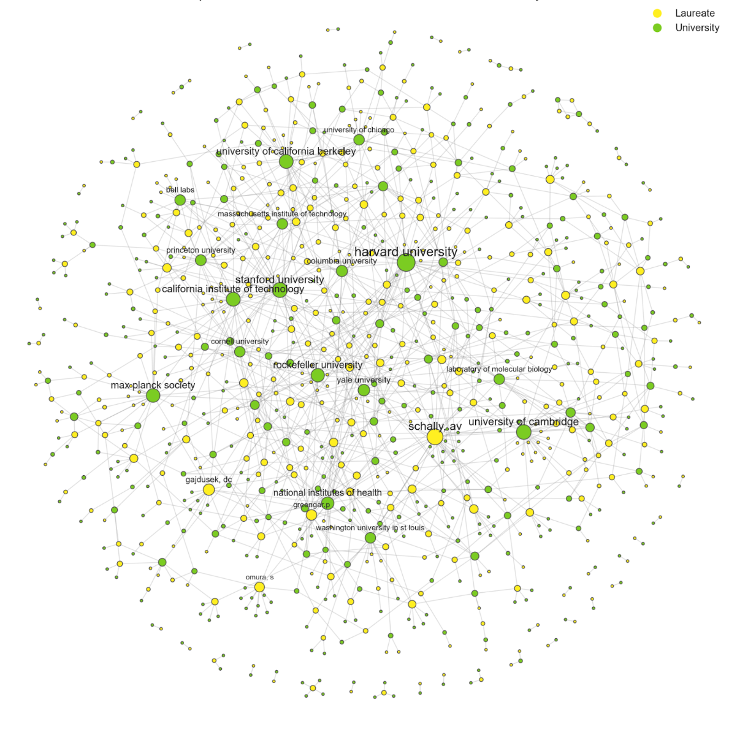Fig. 1: Bipartite Network of the entire dataset

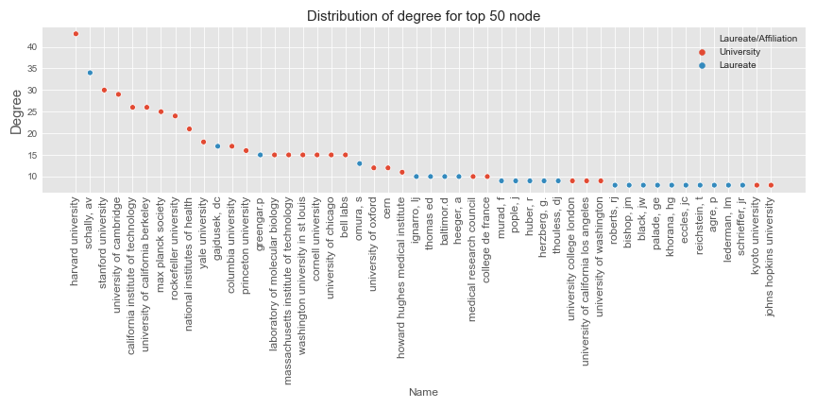  
Top 50 degree distribution in Fig. 1

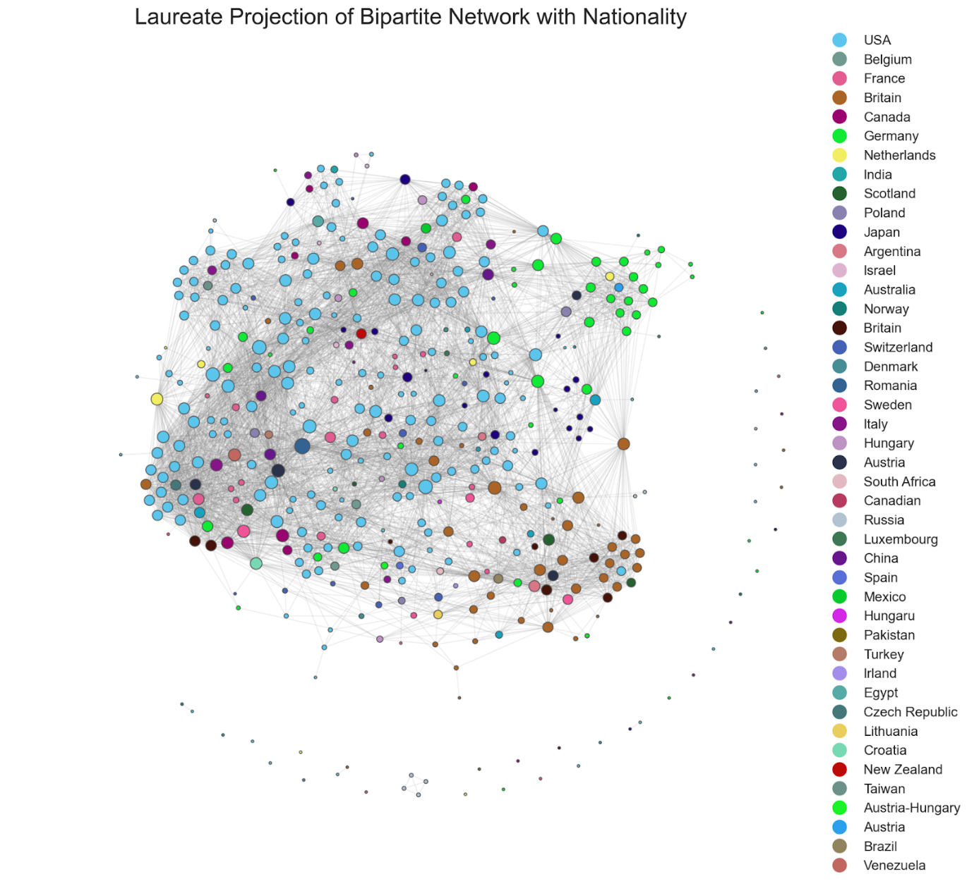Fig. 2: Laureate Projection Network, color by nationality

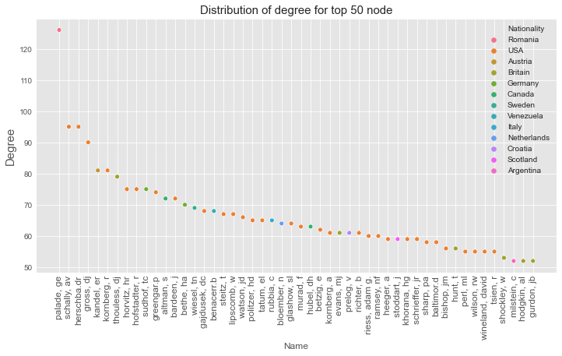

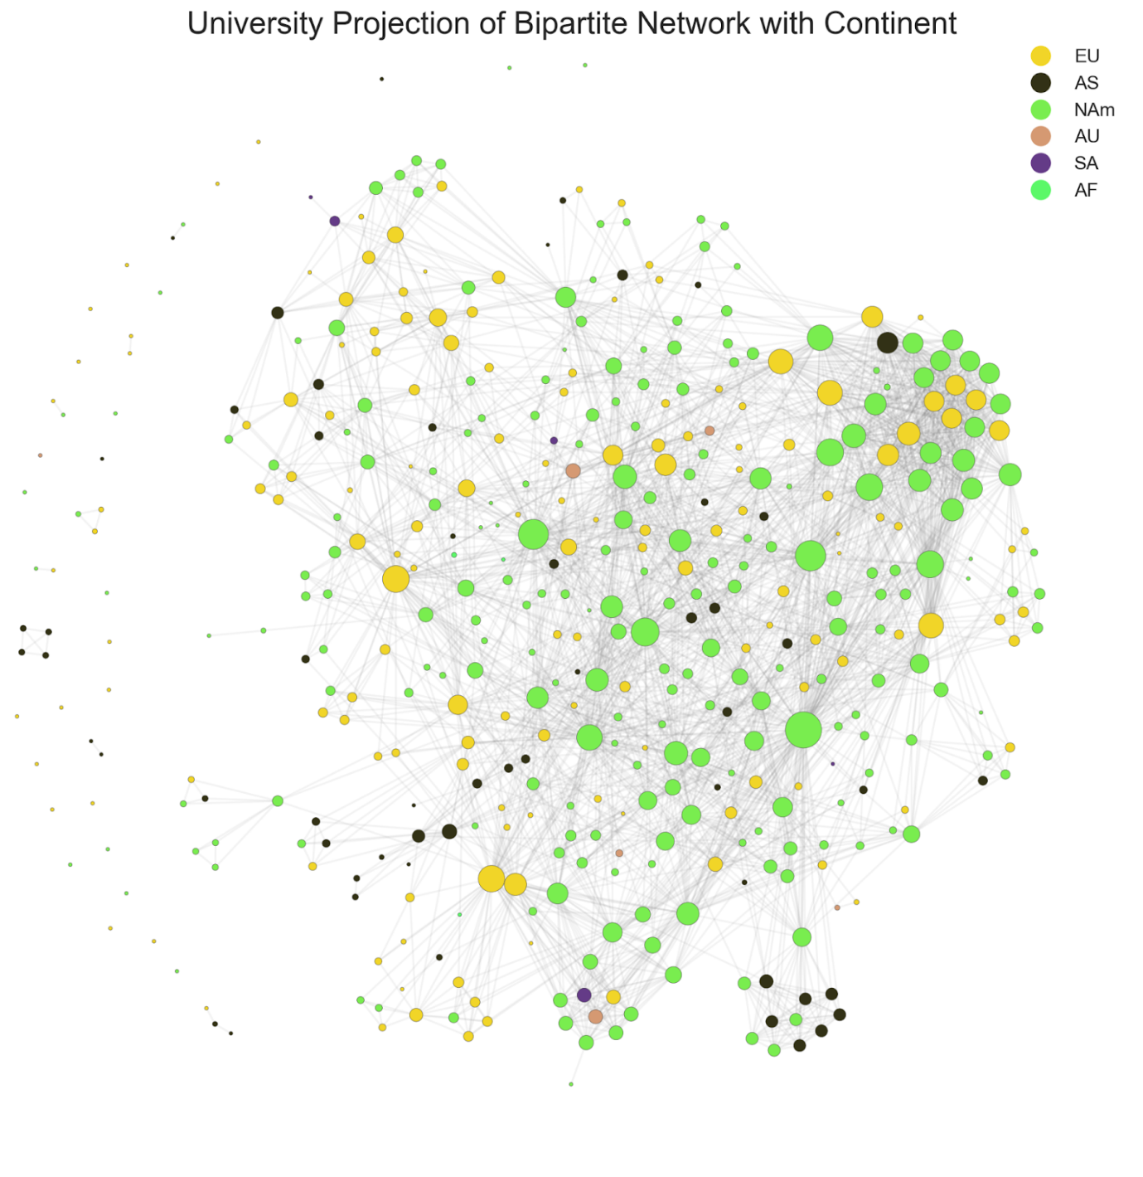 University Projection Network, color by Continent

University Projection Network, color by Continent 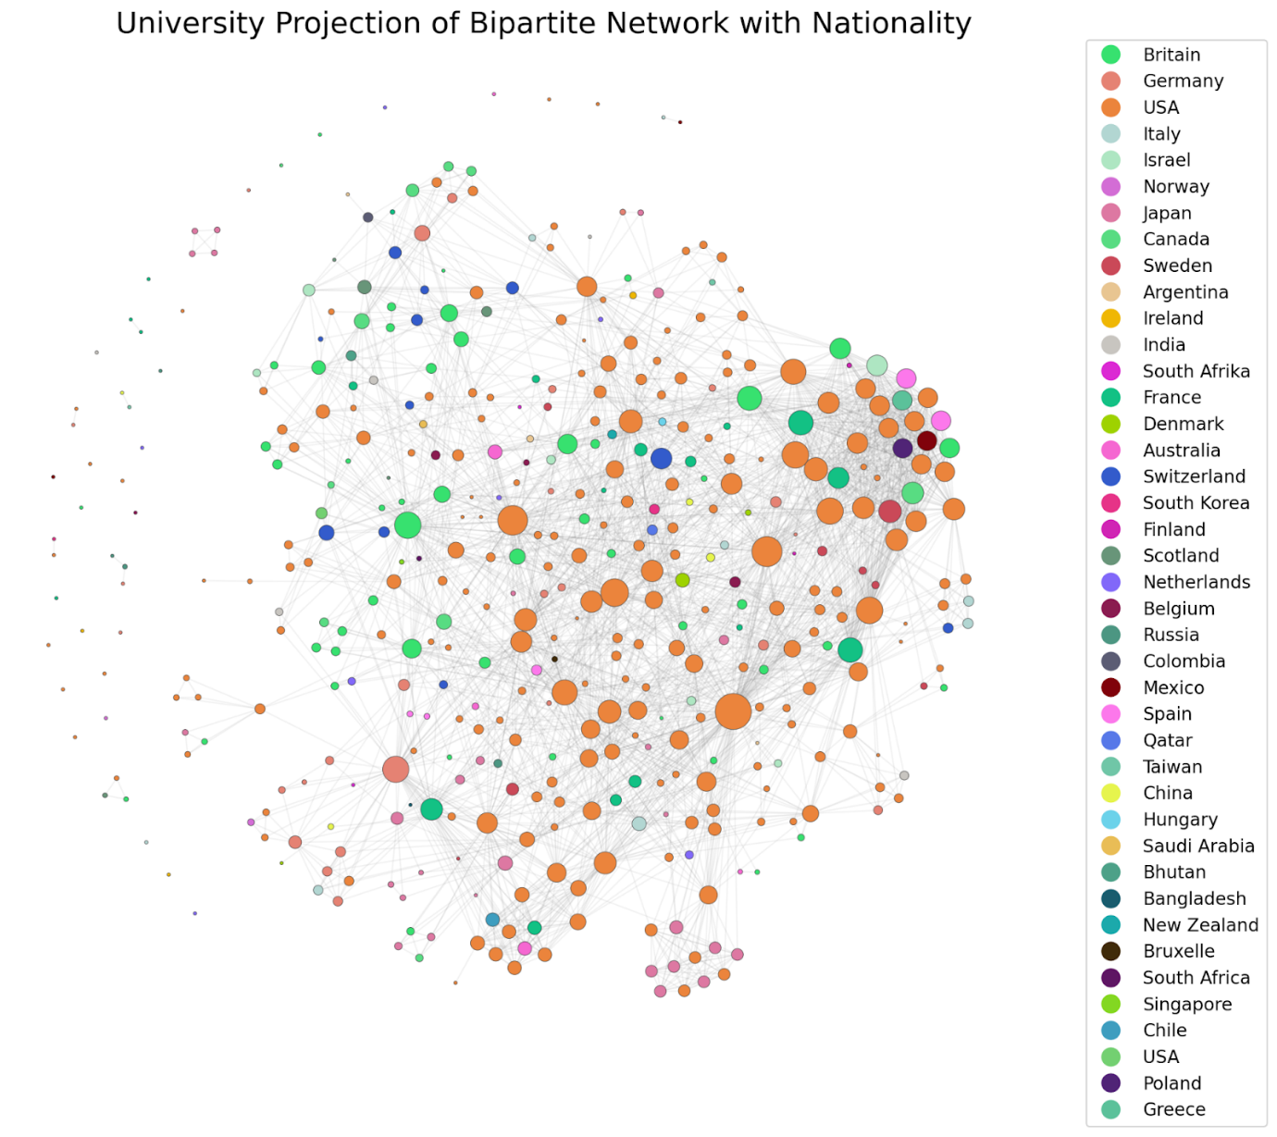

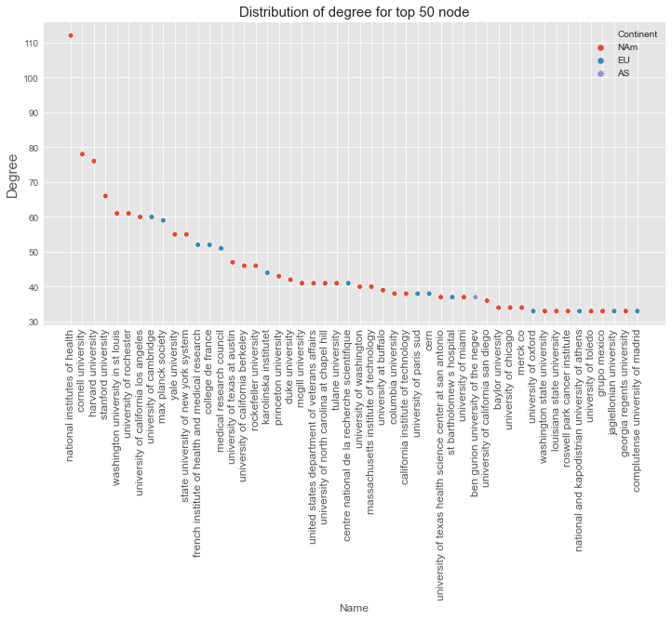

It is worth noting, that the only Asian university on the list (ben gurion university of the negev), is in Israel. It is also worth noting that merck co, is a private company, maybe trying to acquire some science capital?

Networks classified through time

We have decided to use Heinz et al. four periods (Section 3.4): before 1939, 1940-1969, 1970-2000, after 2000 . We do this by only showing the affiliation networks of the Nobel laureates who have won within the given timeframe for each period. The following is the networks for each time period. All the four chapters will have the following structure, and the same networks: A bipartite network with both universities and laureates, a projection of the laureates, and a projection of the universities.

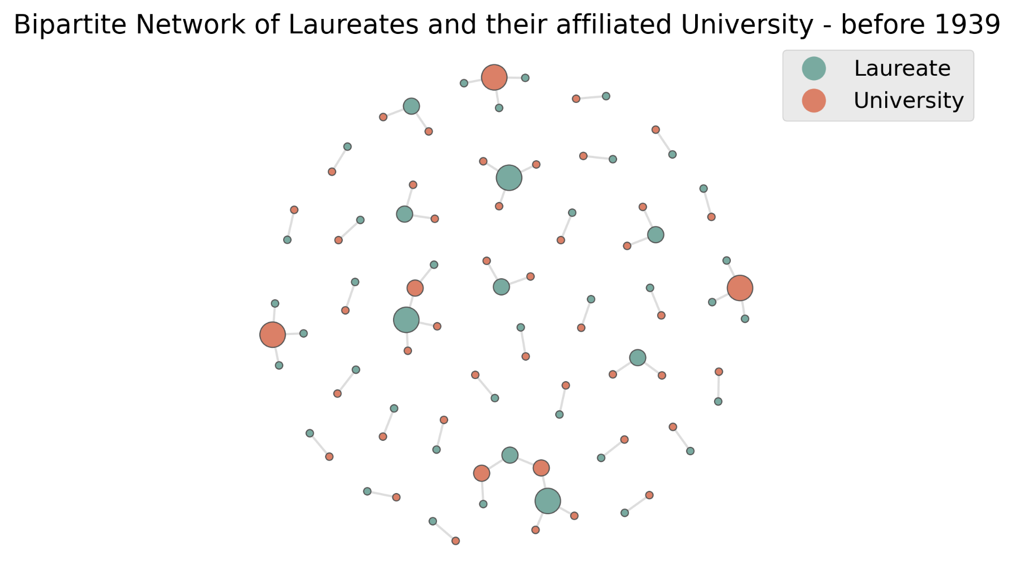Period before 1939

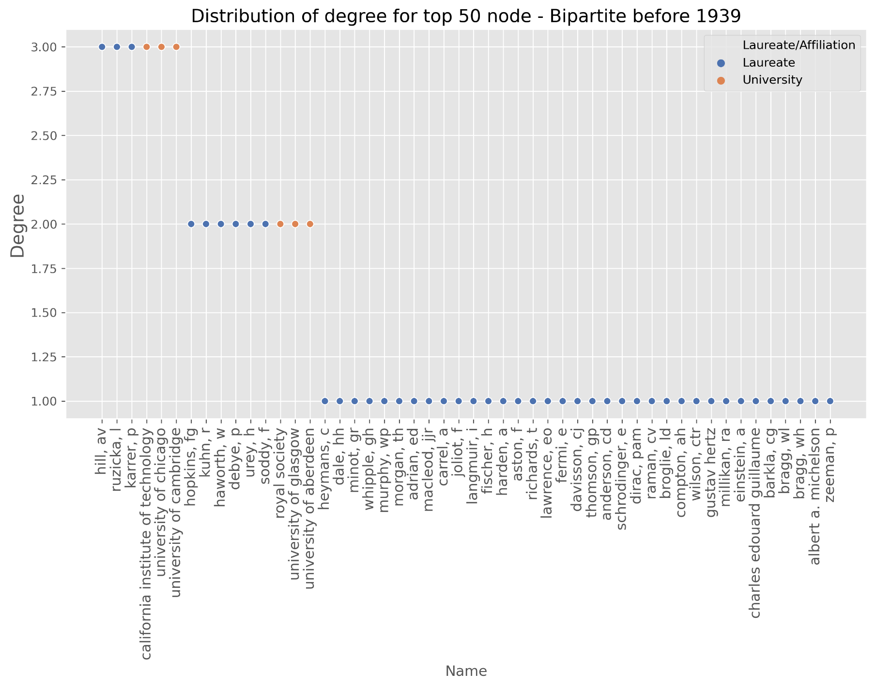

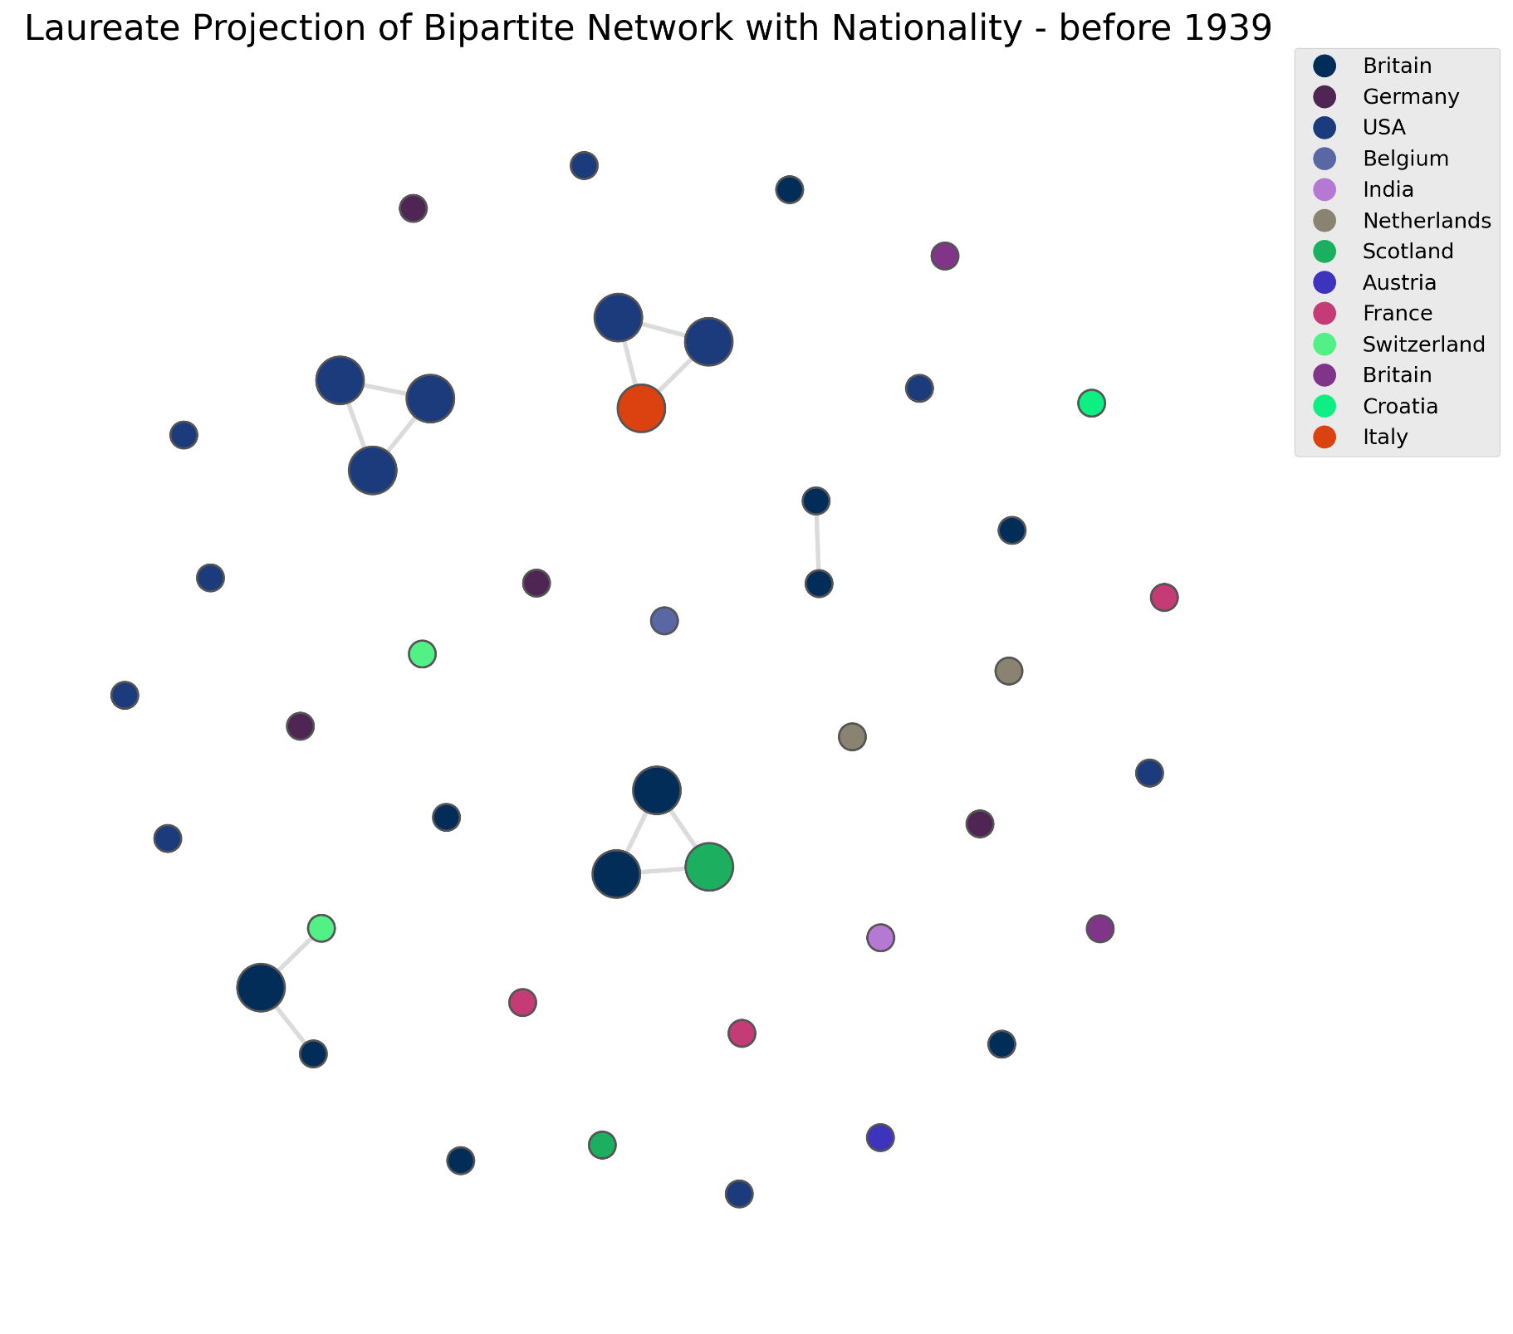

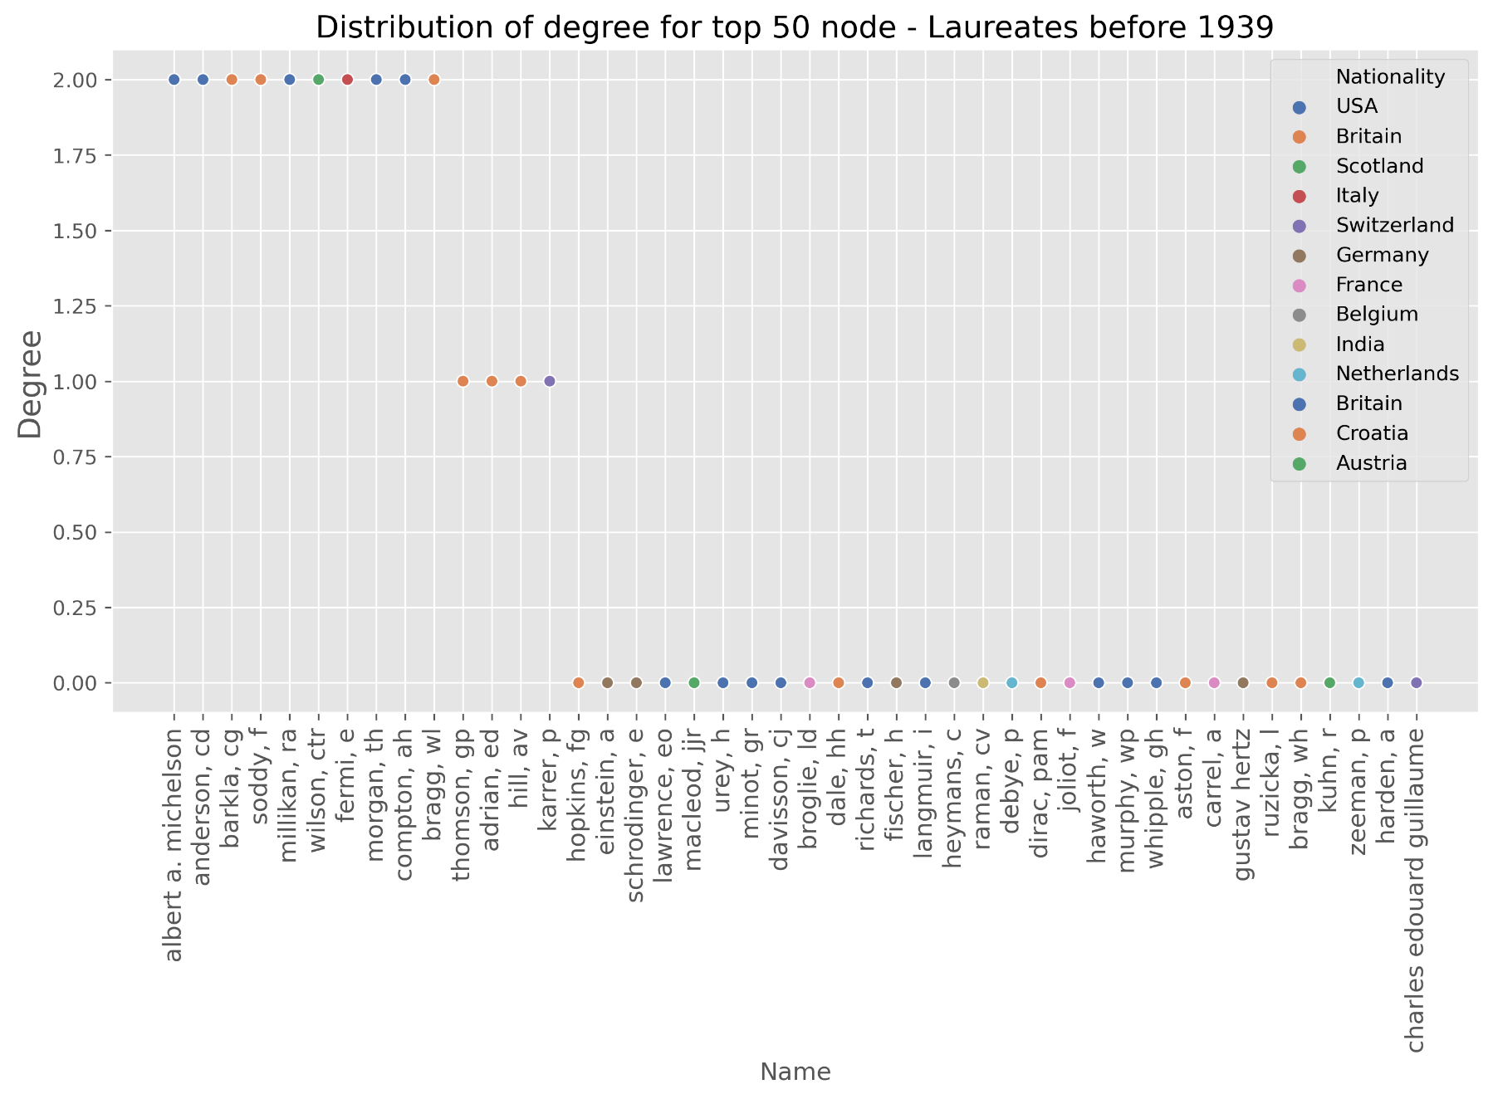

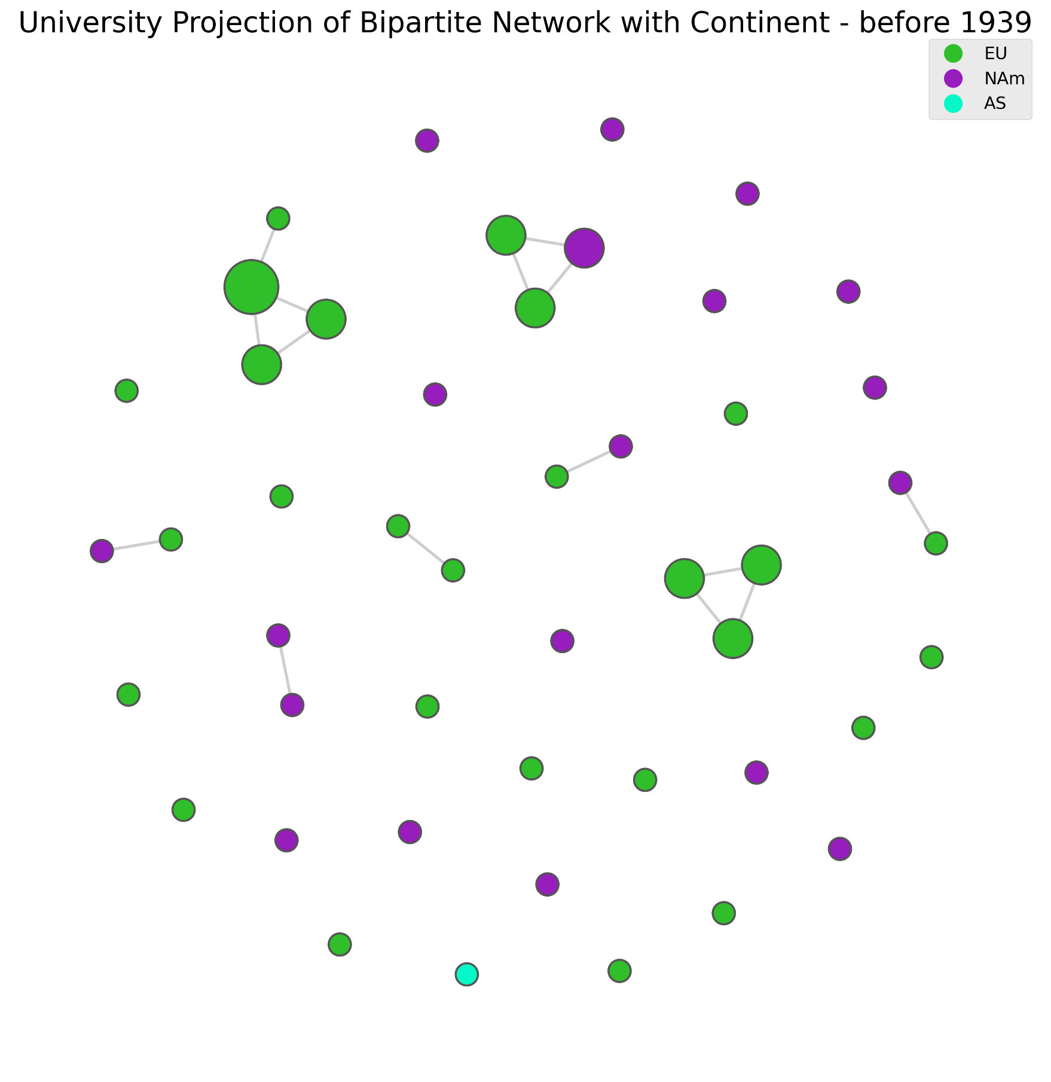

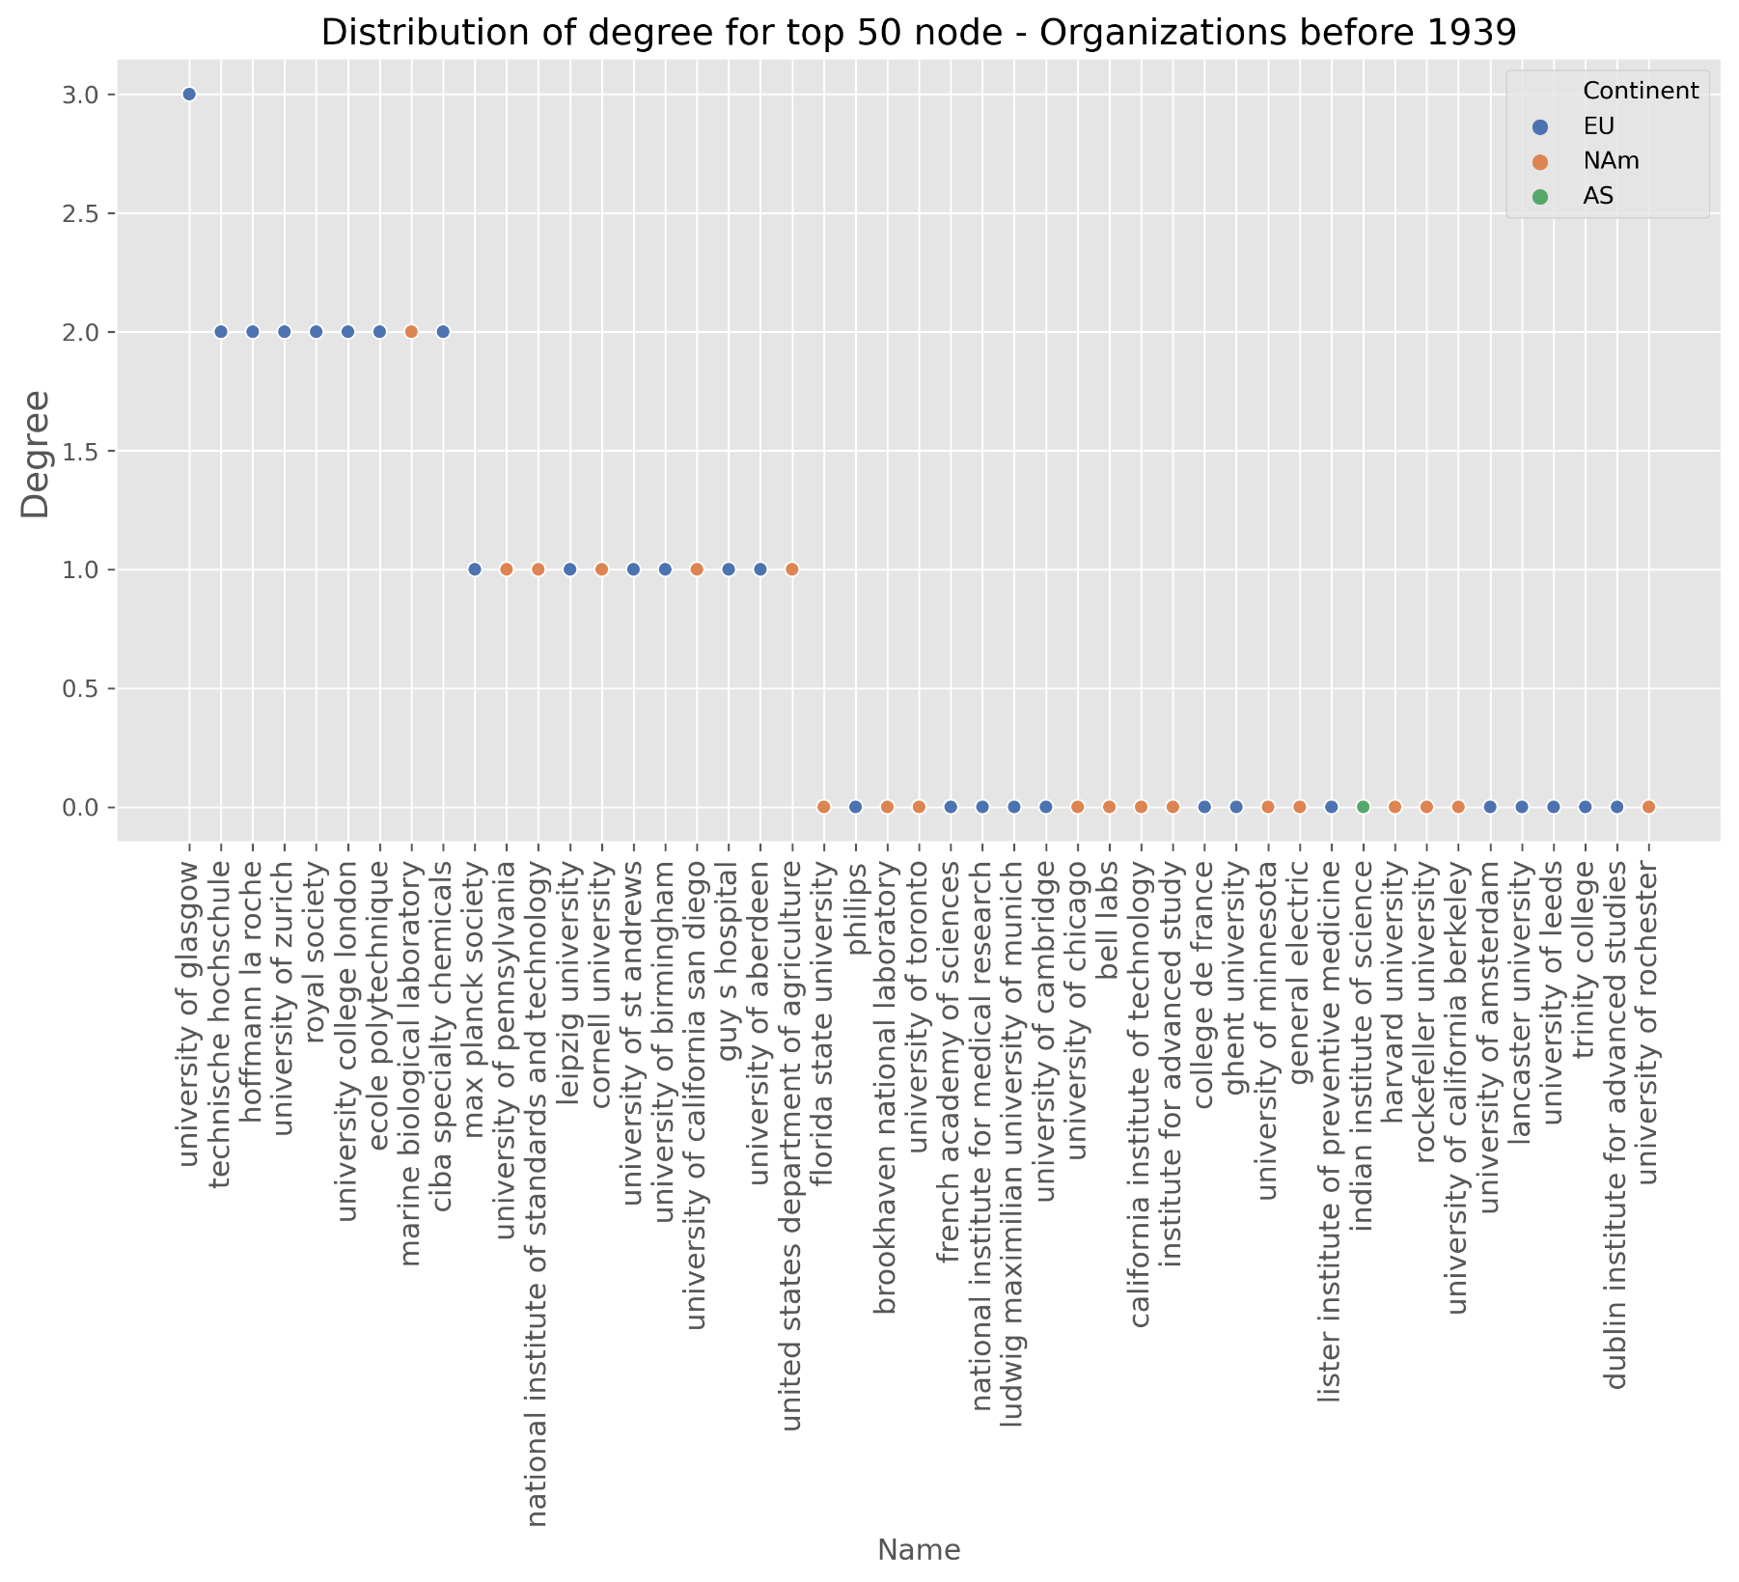

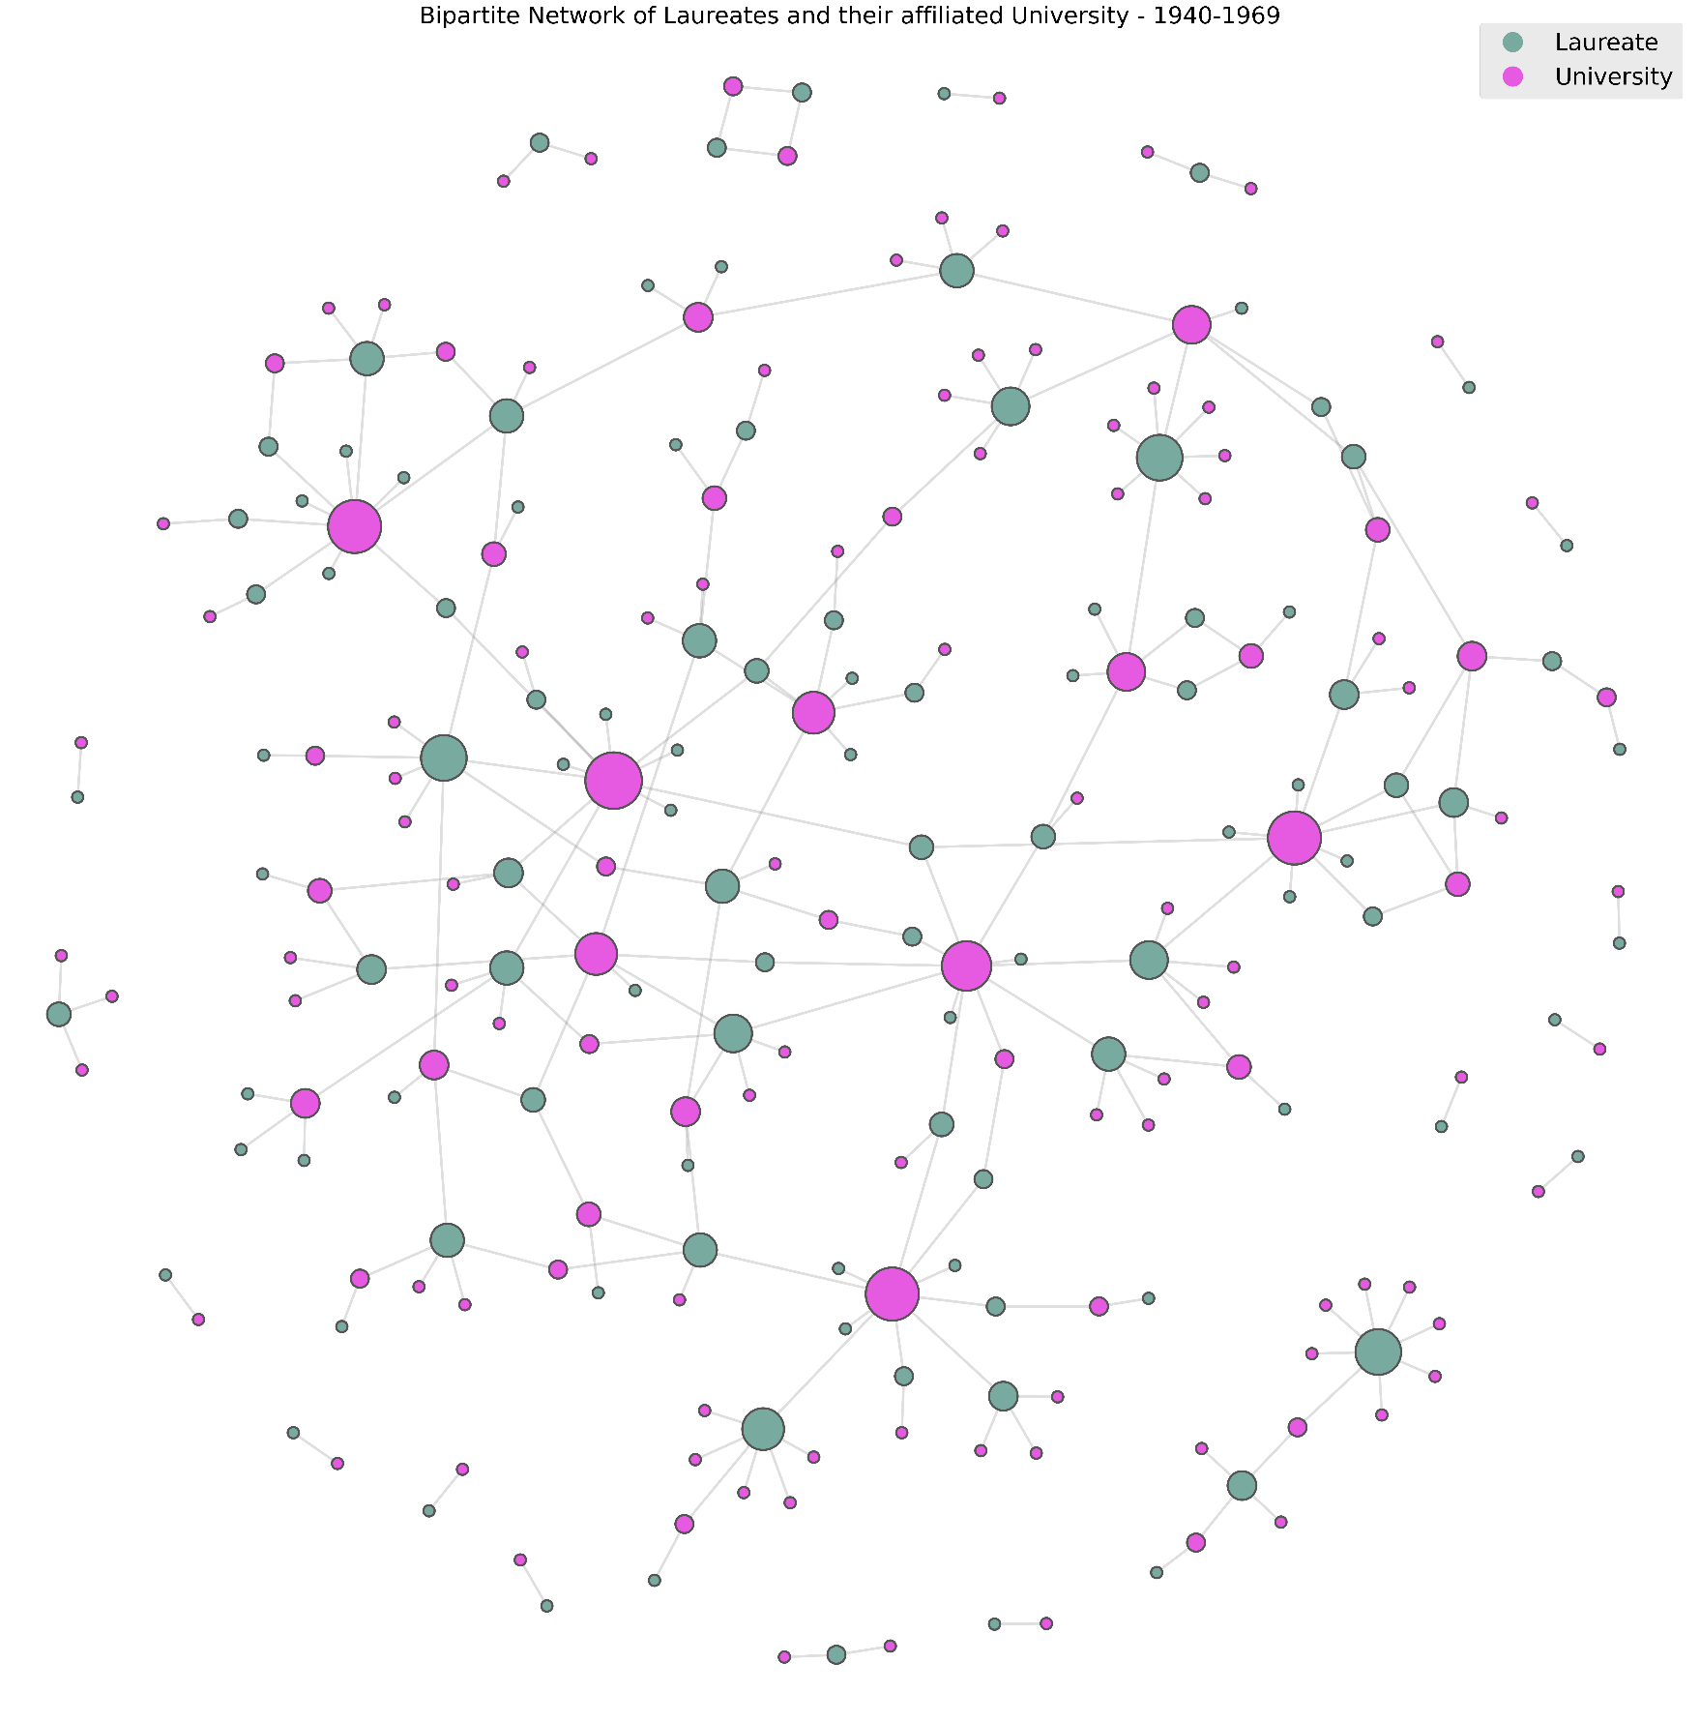Period of 1940-1969

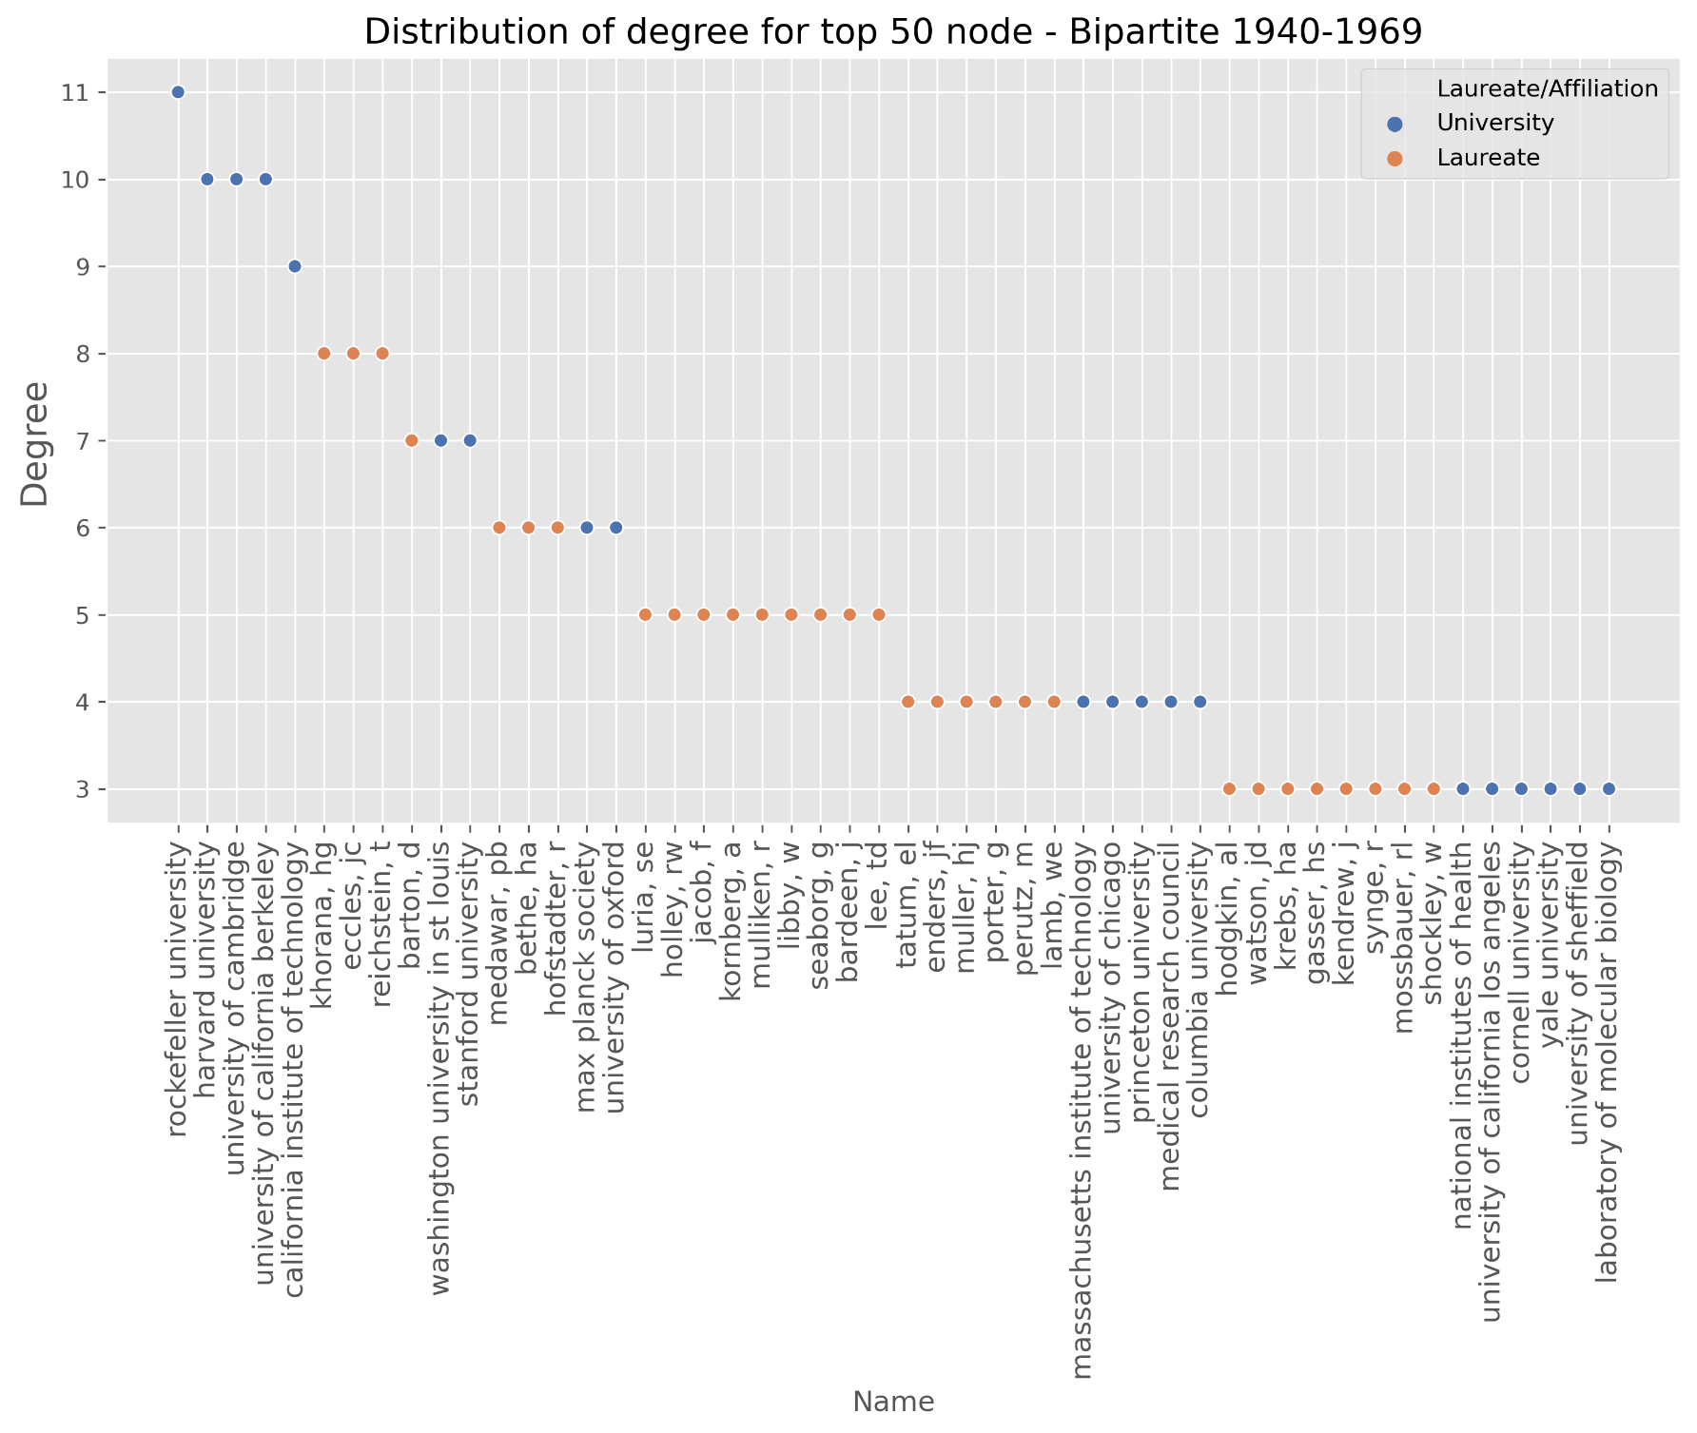

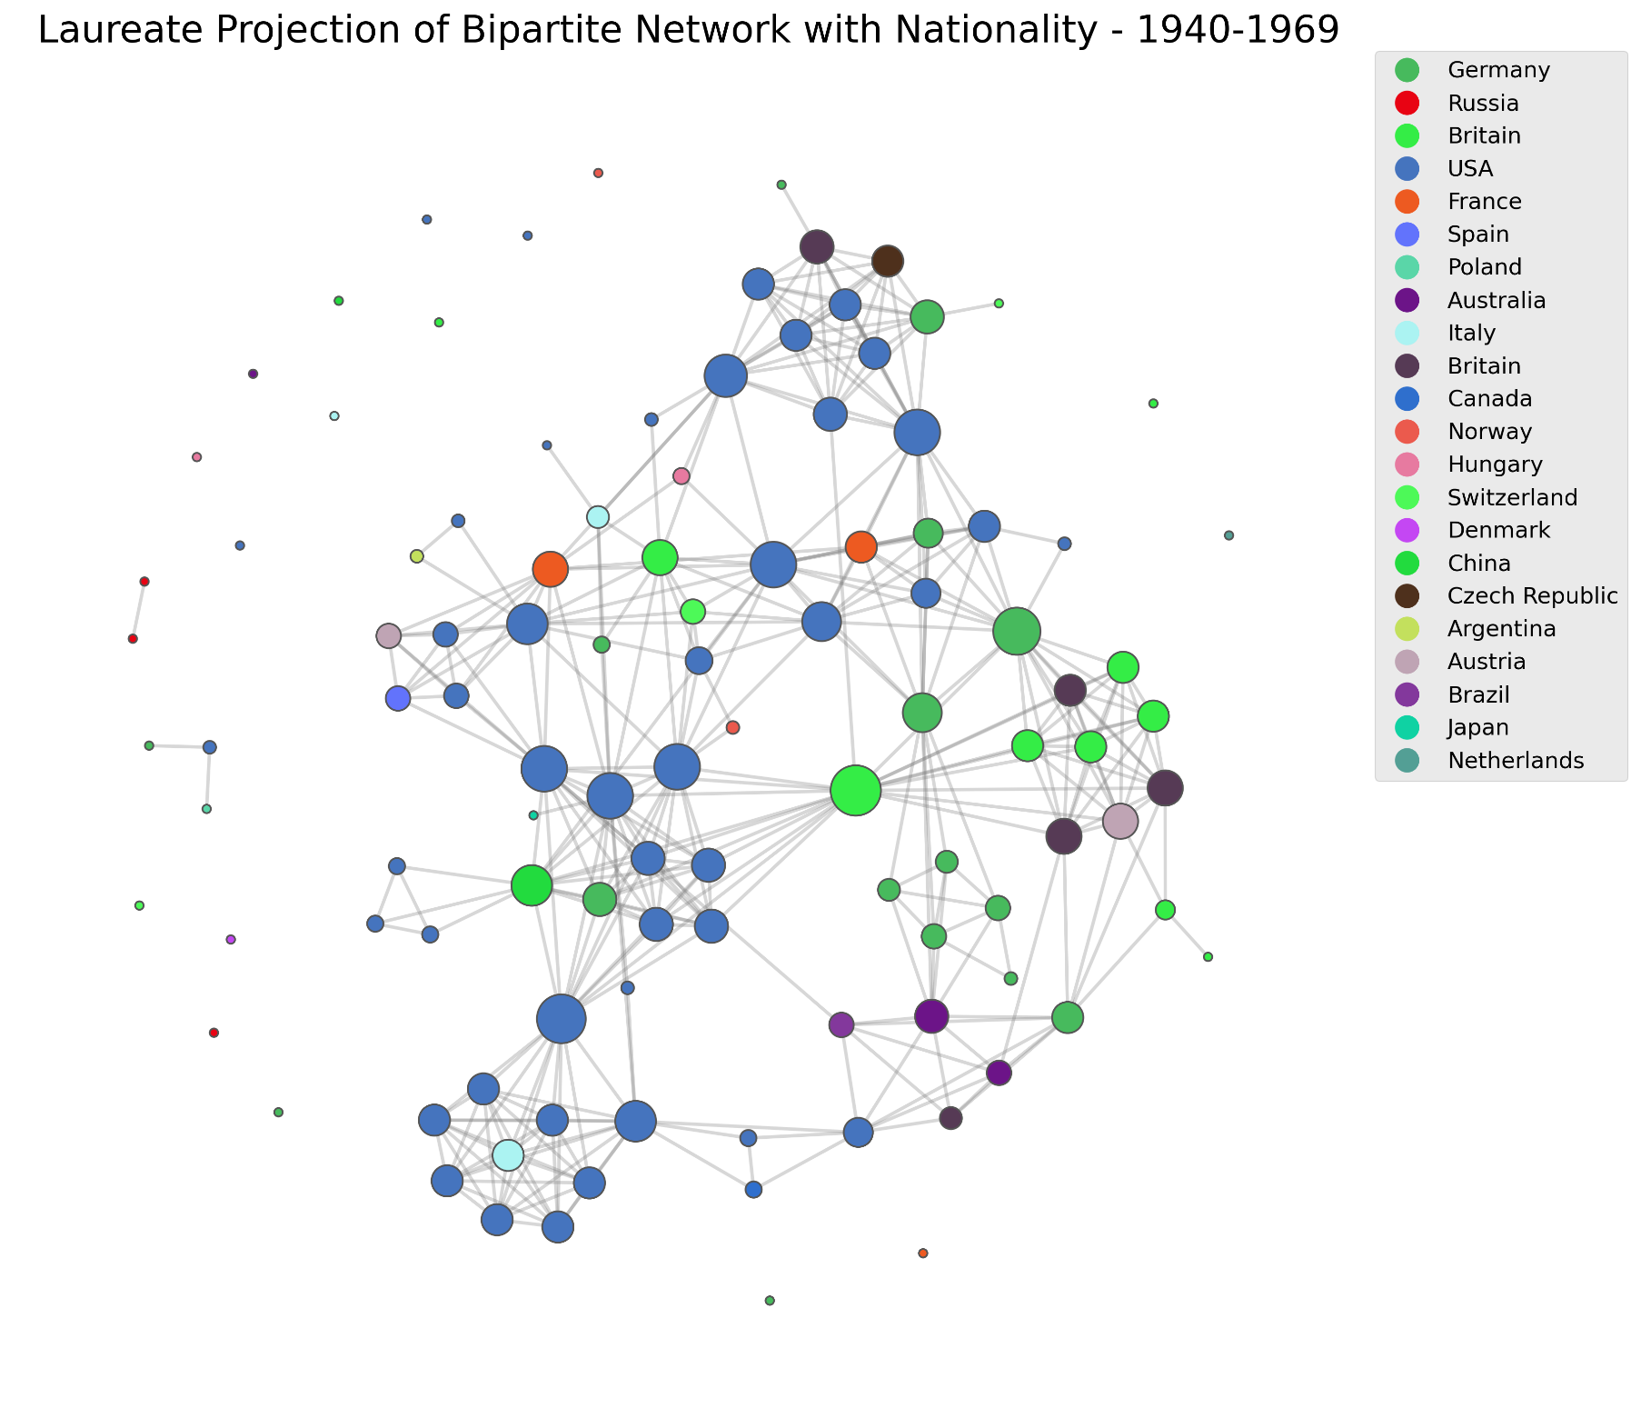

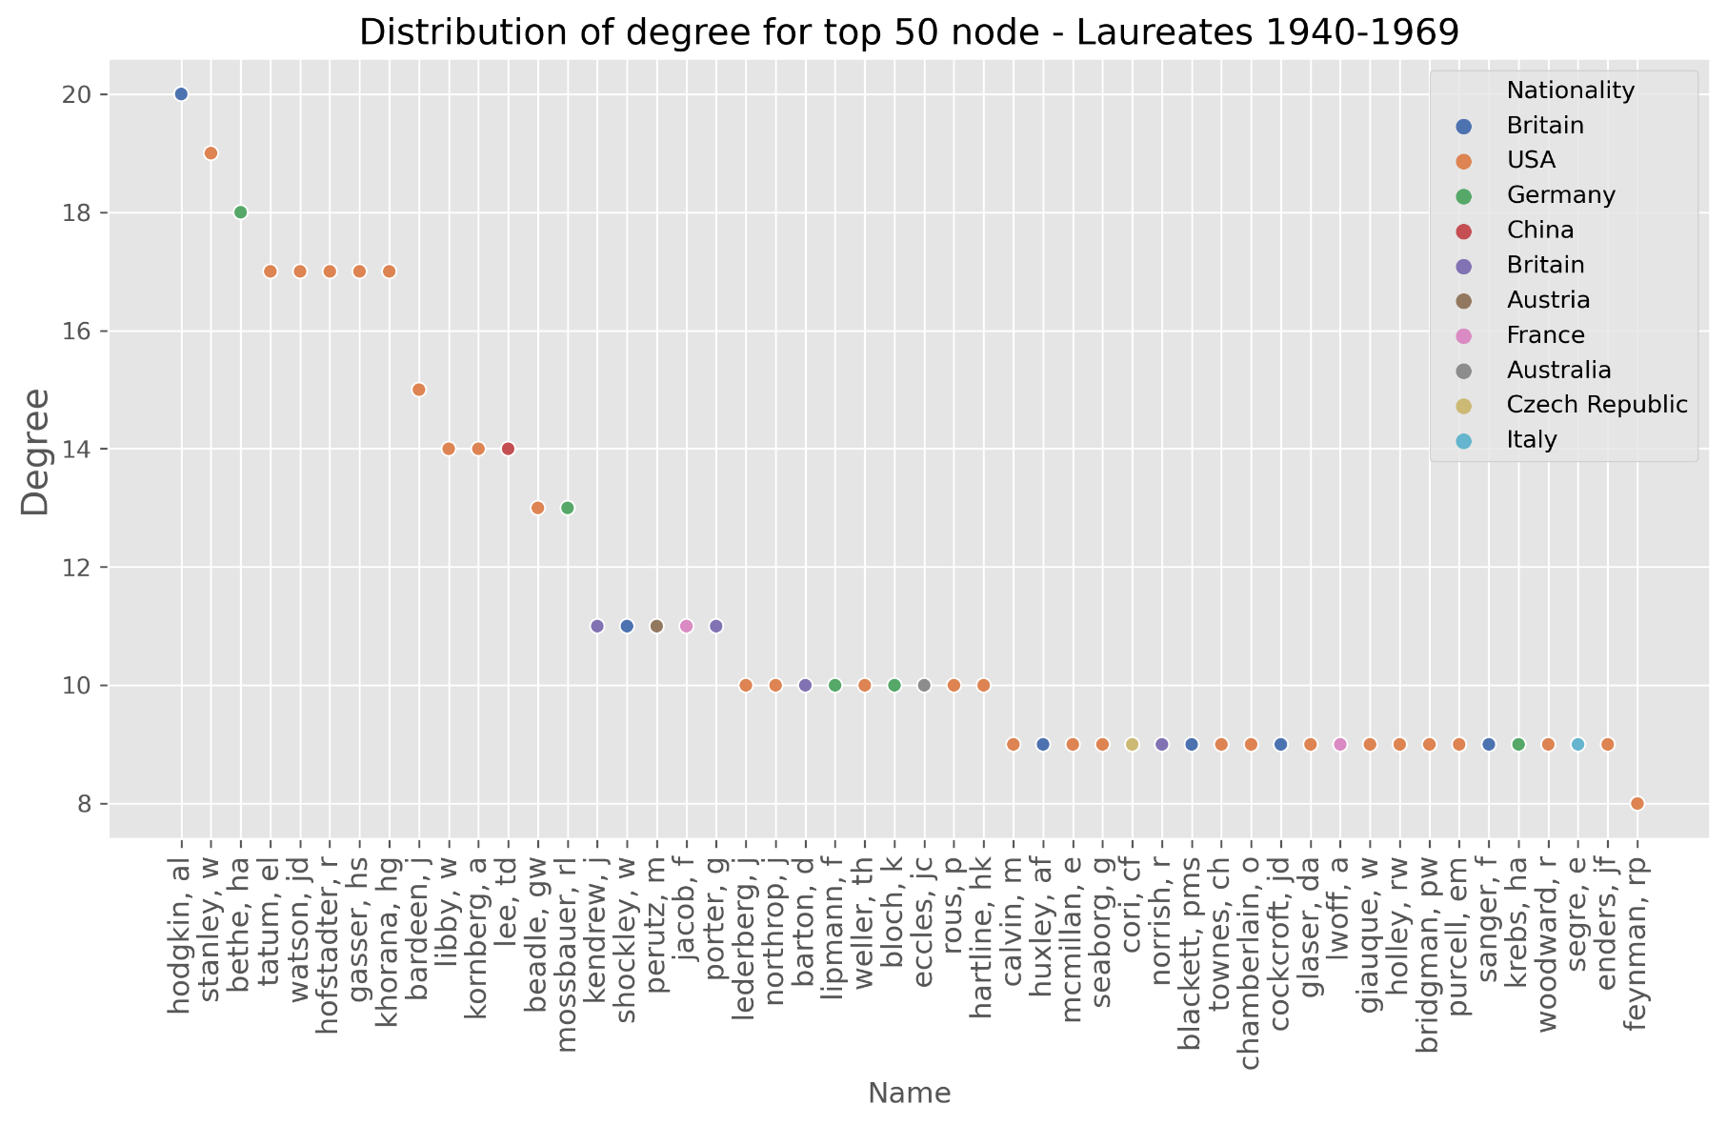

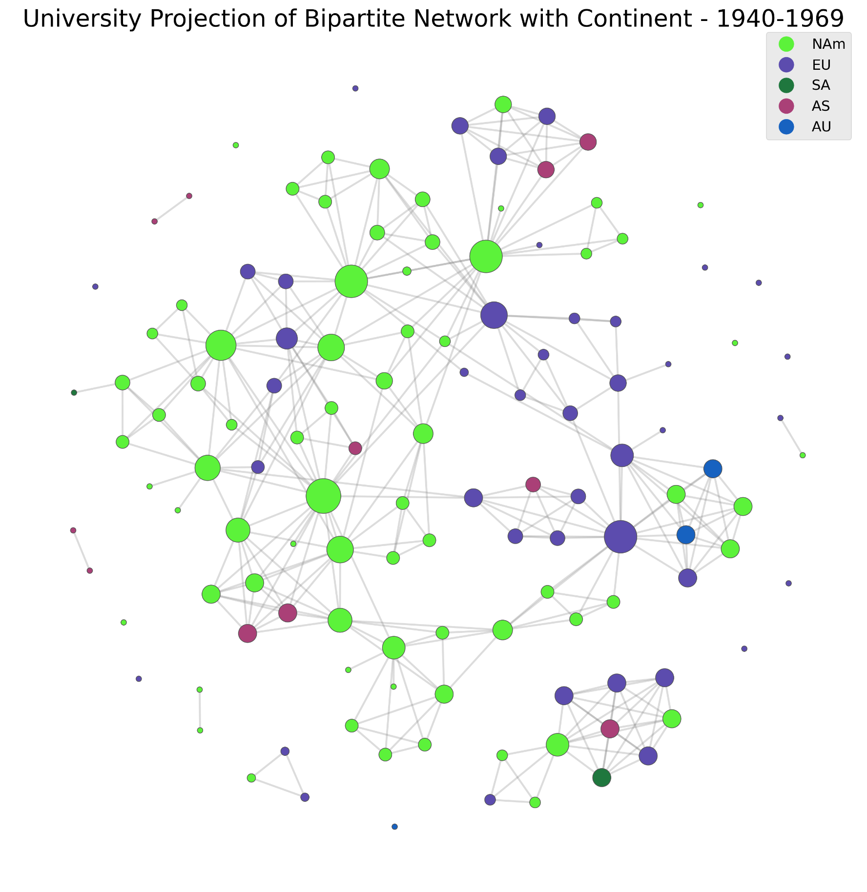

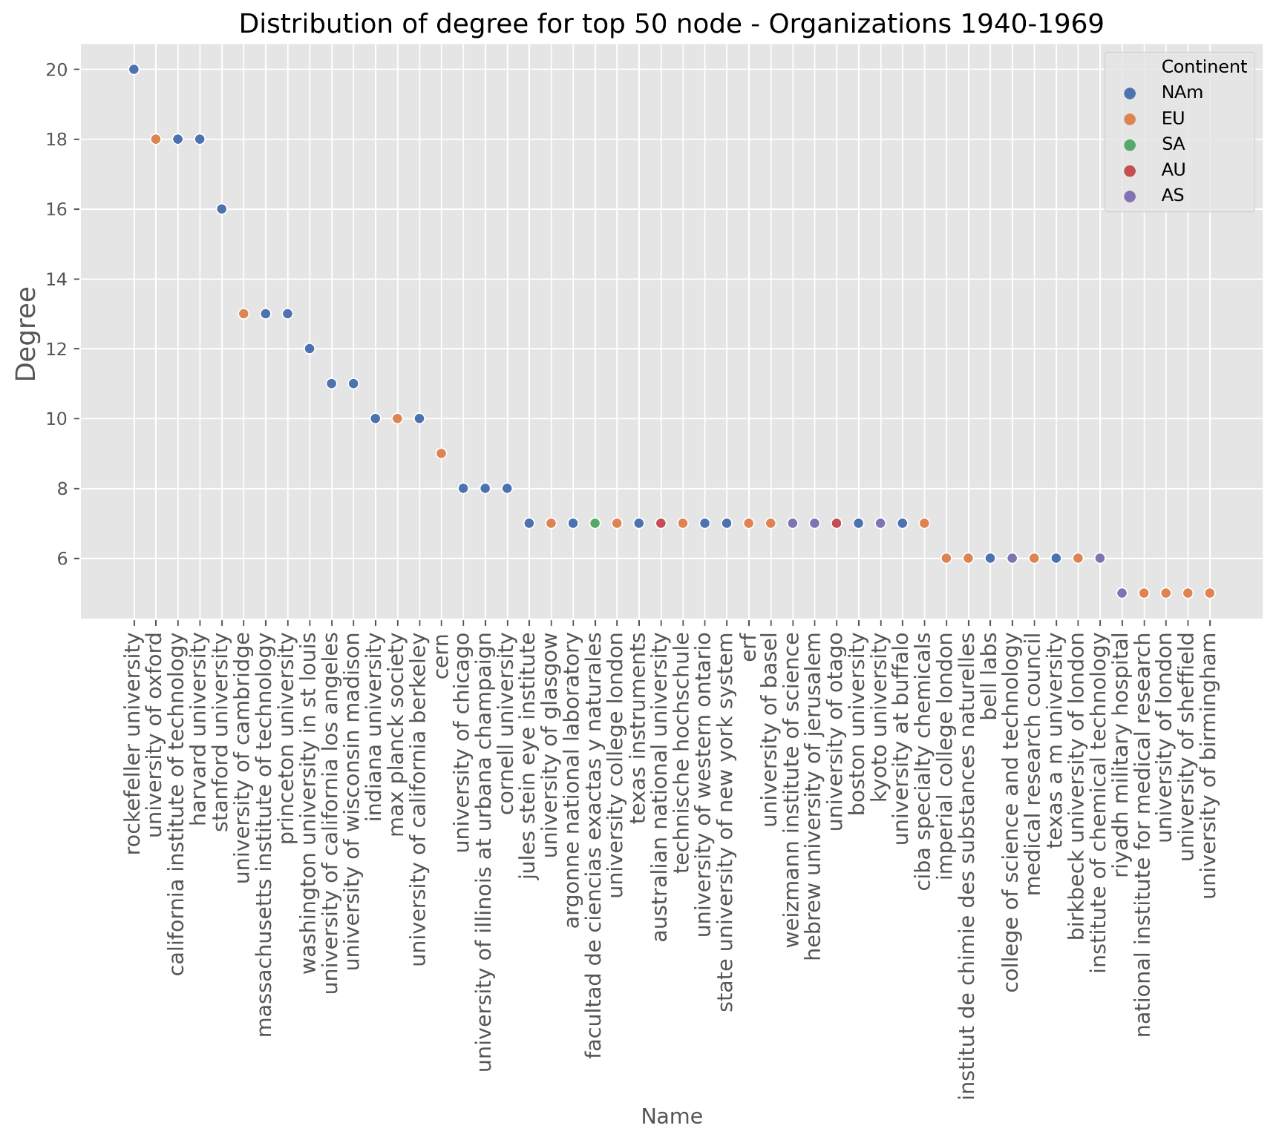

Time period of 1970-1999

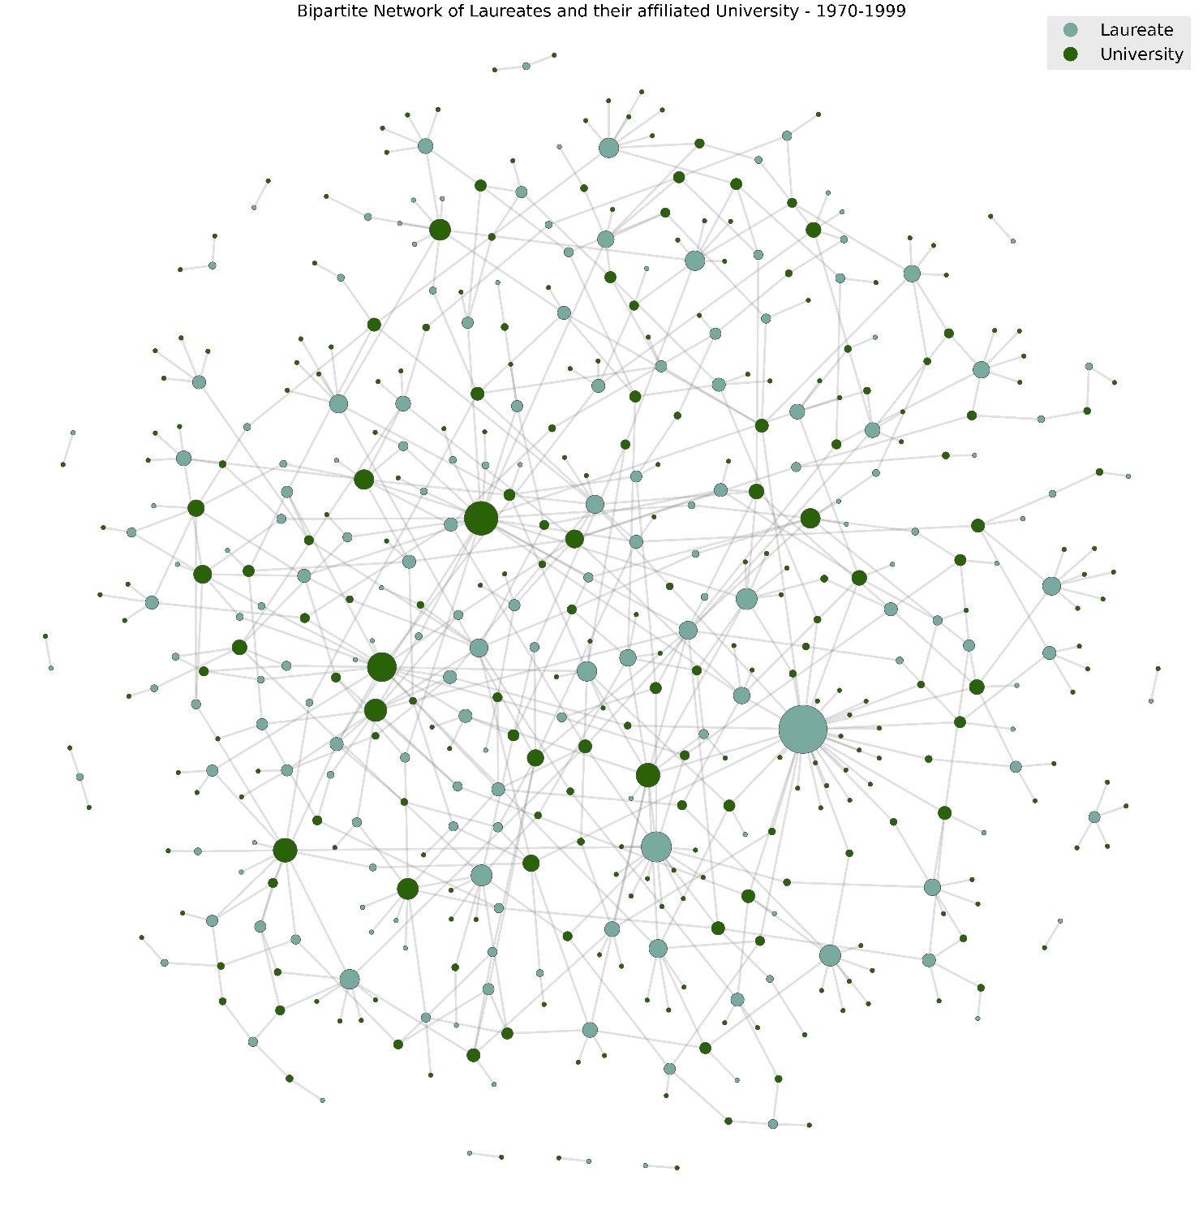

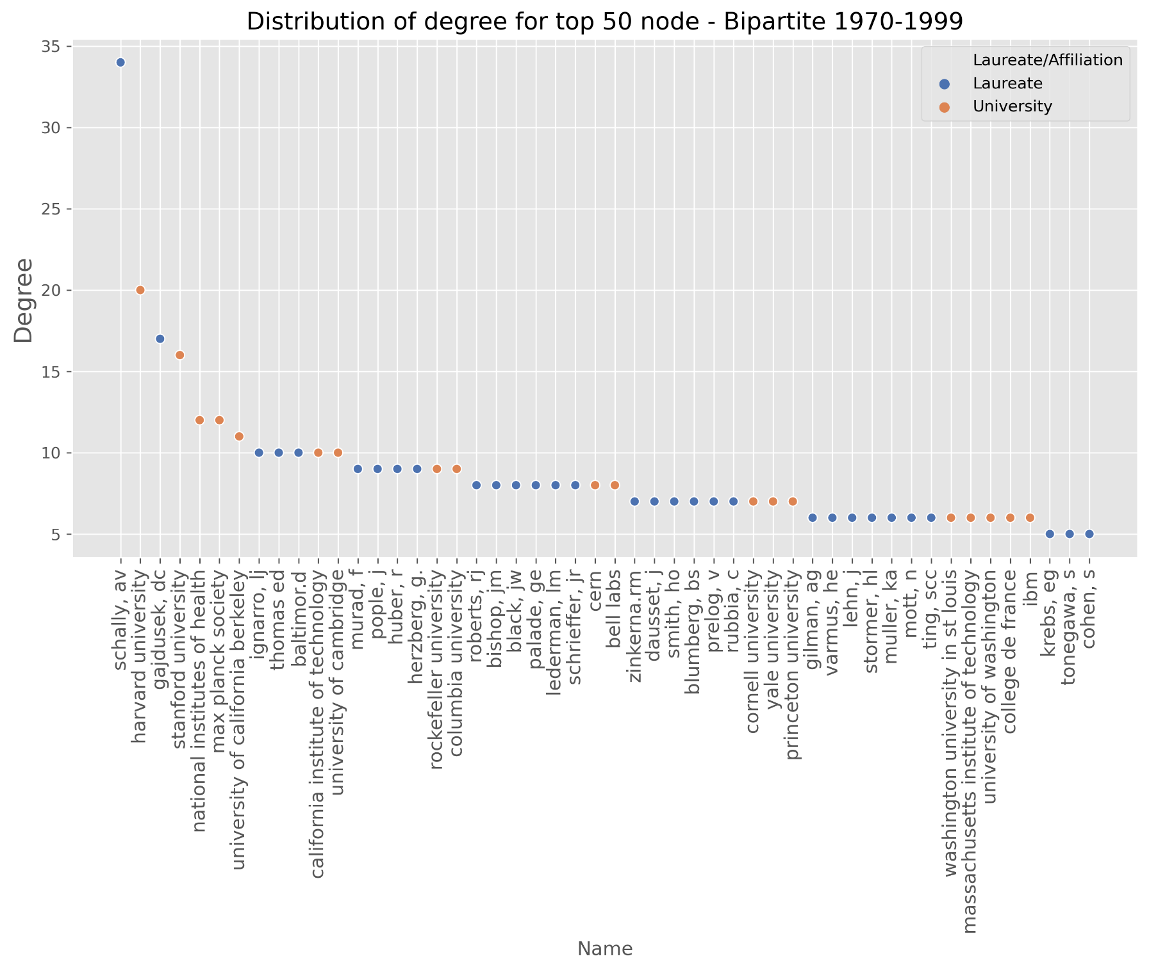

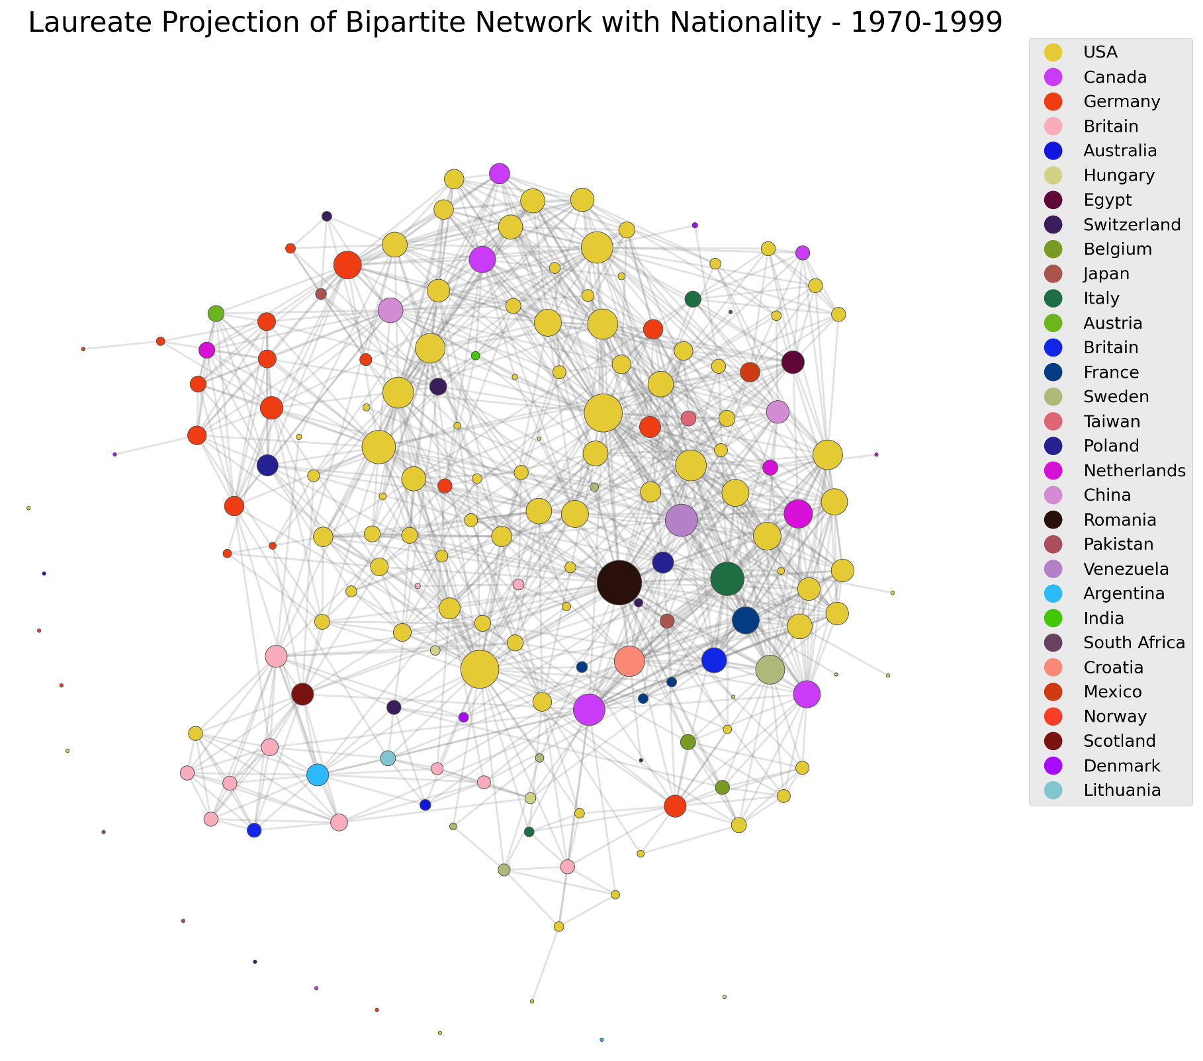

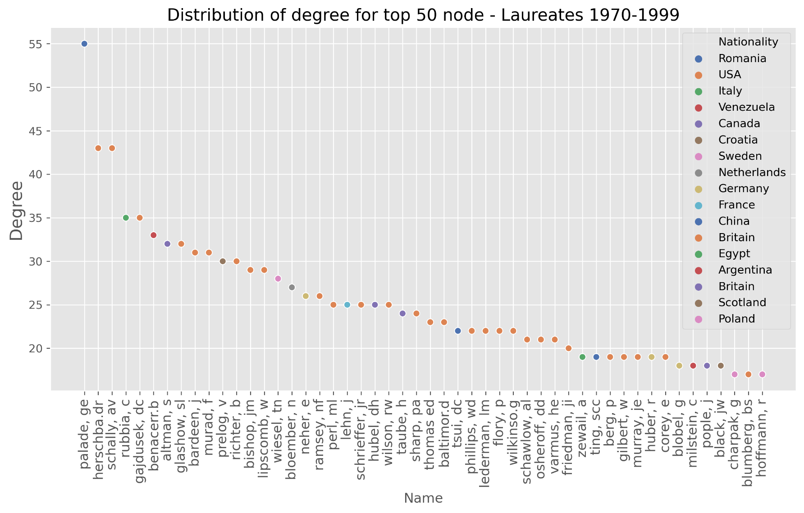

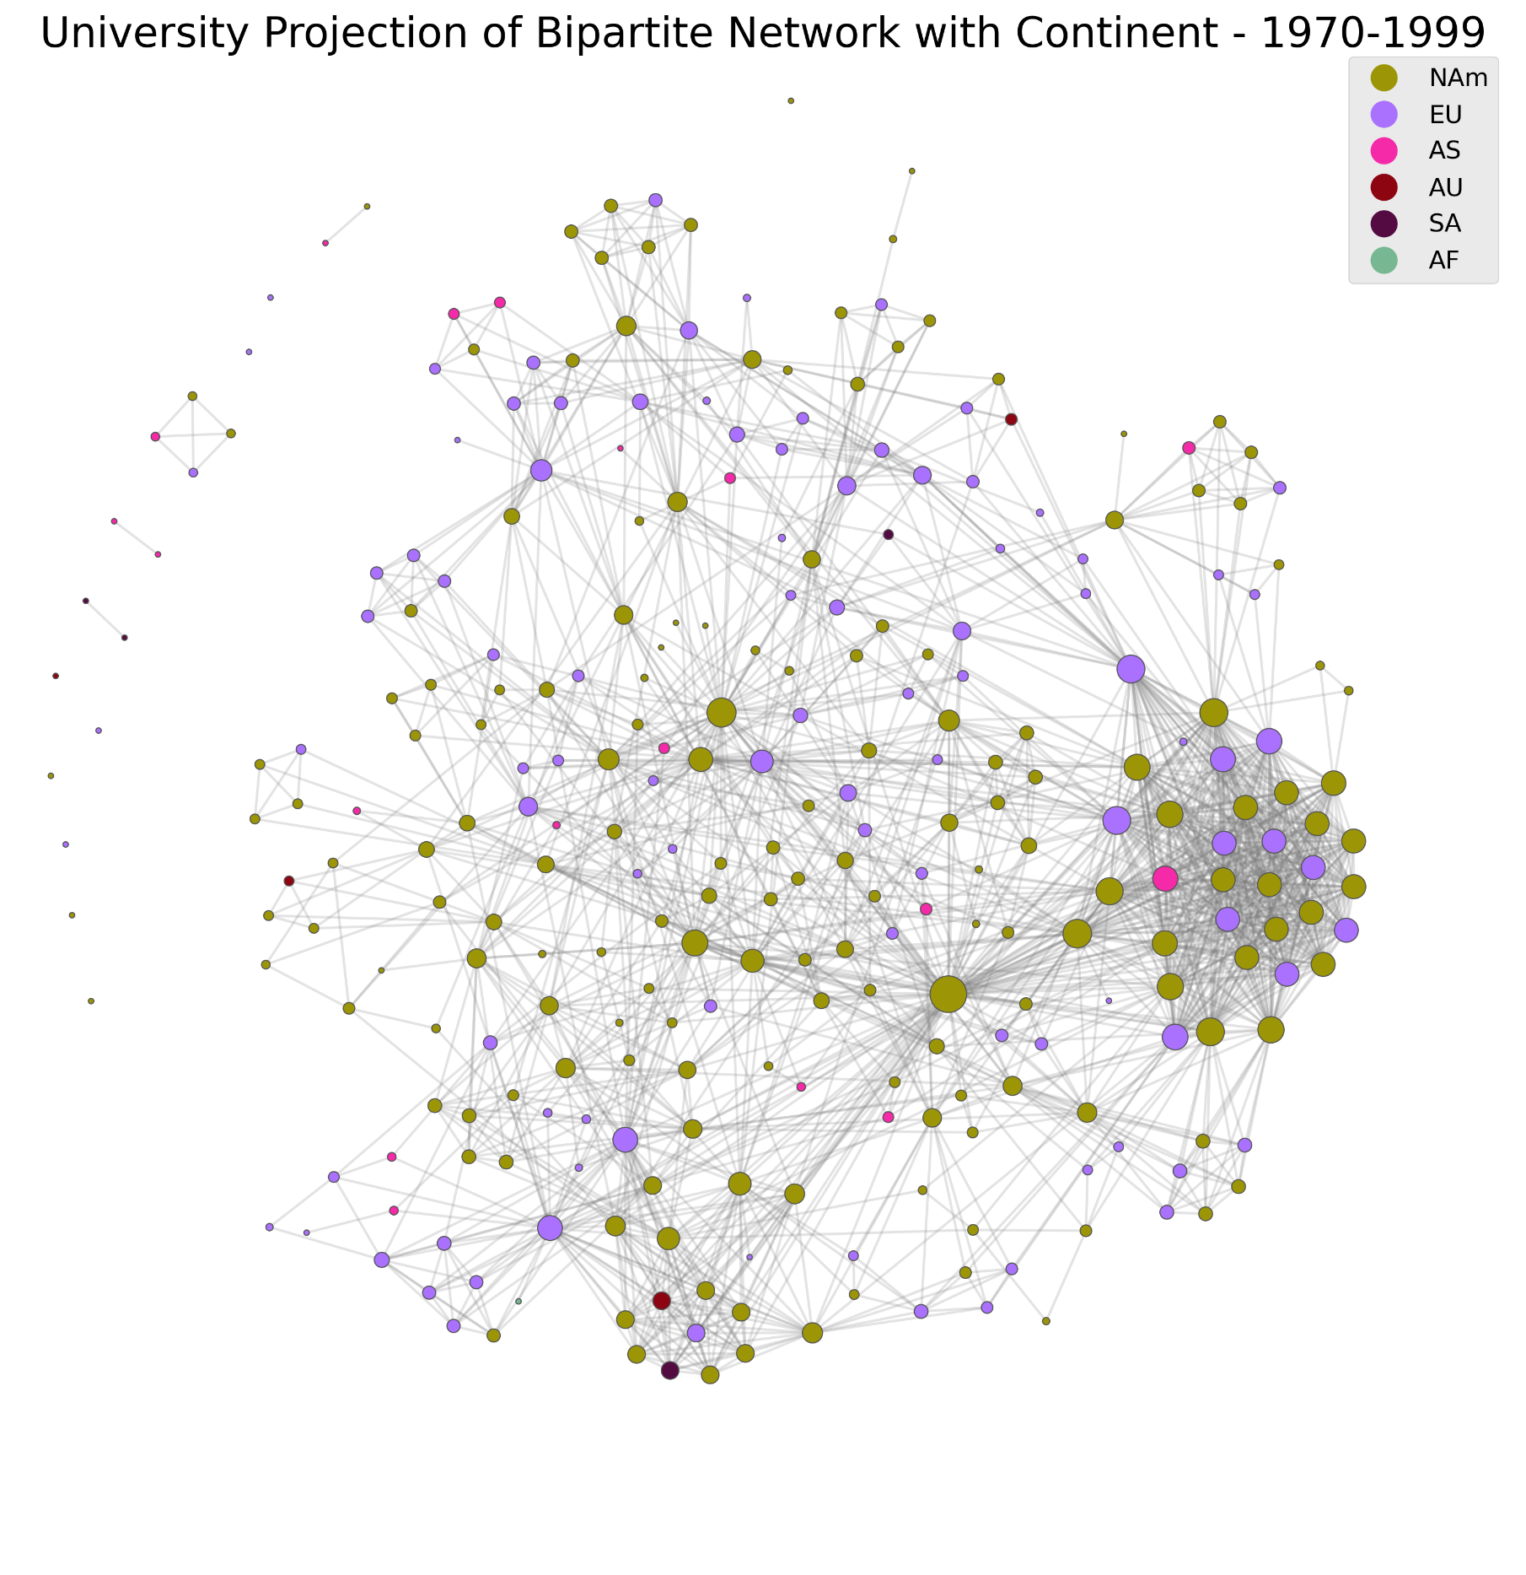

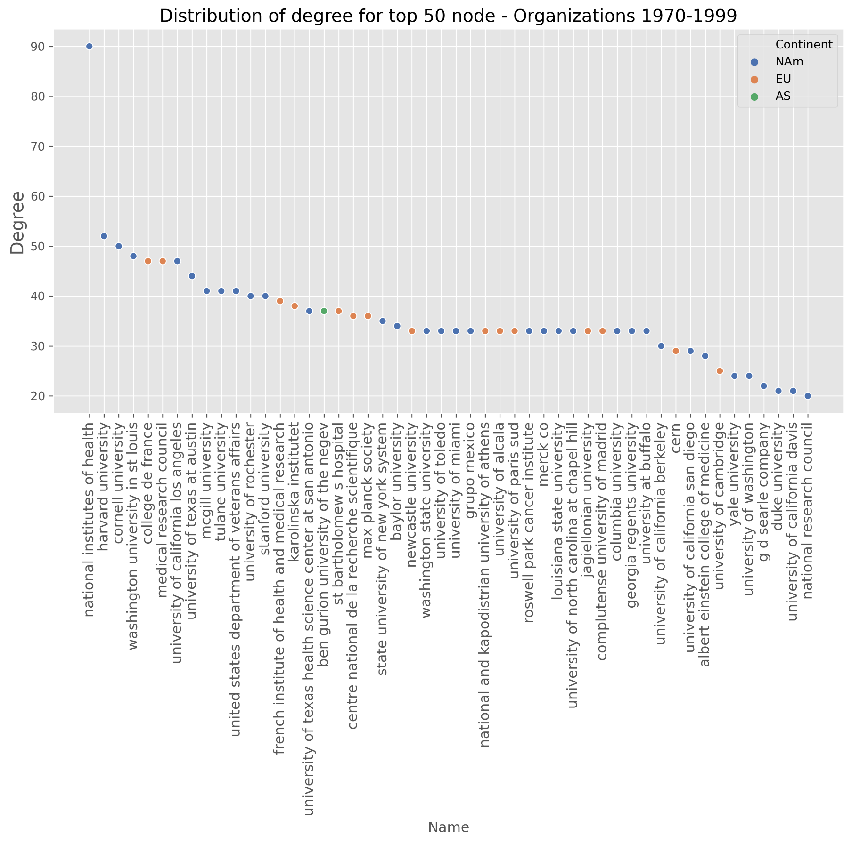

Time period after 2000

